Aligarh Muslim University, Aligarh
Department of Computer Science

LAB FILE



Submitted By: -
Name: Kapil Pandey
Faculty Number: 25CAMSA104
Enrollment Number: GR0588
Course: Master of Computer Application
Subject Name: Laboratory Course-II
Subject Code: CAMS-2P01

Submitted To: -
Prof. Arman Rasool Faridi
Dr. Faisal Anwer
Dr. Md. Ashraf Siddiqui
Ms. Sajida Khatoon
Dr. Mohammad Luqman
Mr. Mohd Umair

Week 1
P1_StudentAddress
You are working on a module to display the address of a student. The system should take the student's address as input and print it.

import java.util.Scanner;
class P1_StudentAddress{
public static void main(String[] args){
Scanner sc = new Scanner(System.in);
System.out.println("Enter your Address: ");
String str1 = sc.nextLine();
System.out.println("Your Address is: ");
System.out.println(str1);
sc.close();
}
}
Output:
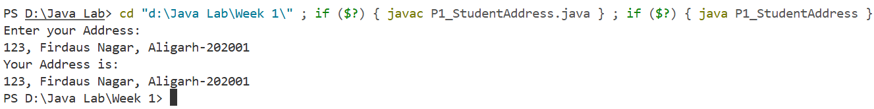
P2_Arithmetic
You need to develop a module that performs basic arithmetic operations (sum, difference, product, quotient, minimum, and maximum) on two integers provided by the user.

import java.util.Scanner;
class P2_Arithmetic{
public static void main(String[] args){
Scanner sc = new Scanner(System.in);
System.out.println("Enter first number");
double num1 = sc.nextDouble();
System.out.println("Enter Second Number");
double num2 = sc.nextDouble();

double sum,diff,mul,quo,max,min;

sum=num1+num2;
diff=num1-num2;
mul=num1*num2;
quo=num1/num2;
max = (num1>num2)?num1 : num2;
min = (num1>num2)?num2 : num1;
System.out.println("Sum is: "+sum);
System.out.println("Diff is: "+diff);
System.out.println("Mul is: "+mul);
System.out.println("Qou is: "+quo);
System.out.println("Max is: "+max);
System.out.println("Min is: "+min);
}
}
Output:
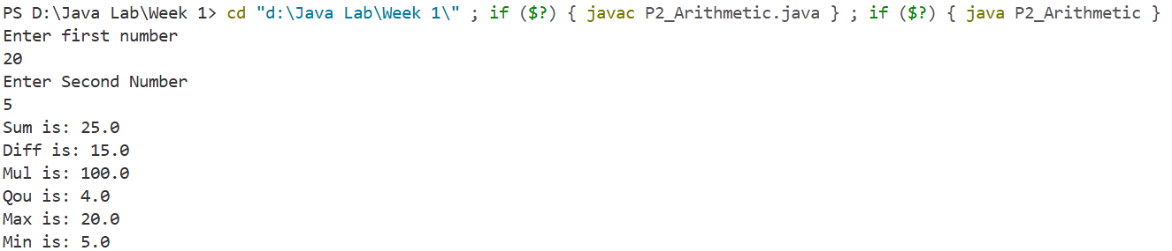
P3_Temperature
The system needs a module to convert temperatures from Fahrenheit to Celsius. The formula for conversion is C= F−32/1.8

import java.util.Scanner;
class P3_Temperature{
public static void main(String[] Args){
Scanner sc = new Scanner(System.in);

double fahr[] = new double[5];
double celc[] = new double[5];
for(int i=0;i<fahr.length;i++){
System.out.println("Enter Temperature in fahrenheit: ");
fahr[i] = sc.nextDouble();
celc[i]= (fahr[i]-32)/1.8;
}

System.out.println("\nSno\t fahr\t celc\t");
for(int i=0;i<fahr.length;i++){
System.out.println(i+"\t"+fahr[i]+"\t"+celc[i]);
}

}
}
Output:
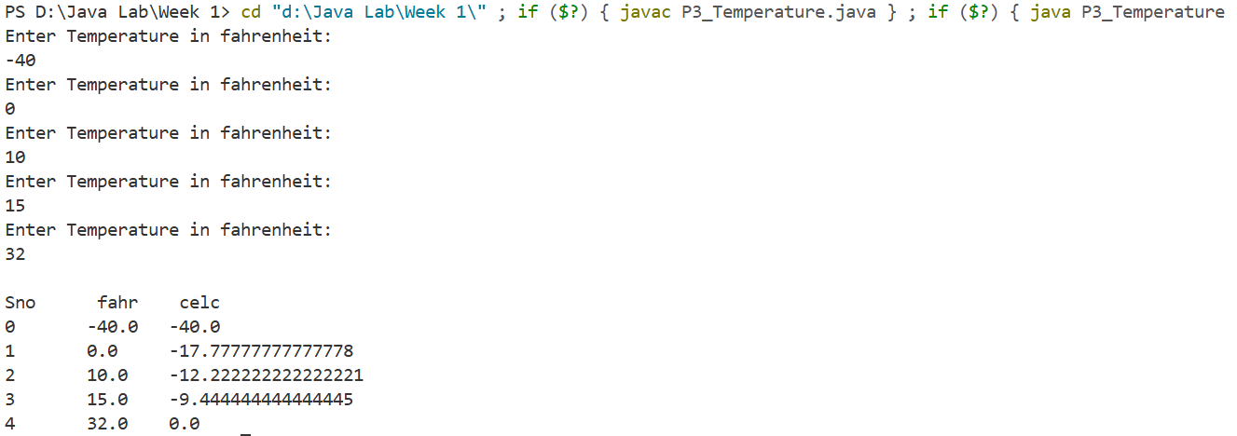

P4_NumberOperations
You are required to write a program that performs various operations on a double variable num. The operations include finding the round, ceil, floor values, and casting to an integer.

import java.util.Scanner;
import java.lang.Math;
class P4_NumberOperations{
public static void main(String[] args){
Scanner sc = new Scanner(System.in);
System.out.println("Enter a double number");
double num = sc.nextDouble();

System.out.println("Round of "+num+" is: "+Math.round(num));
System.out.println("Ceil of "+num+" is: "+Math.ceil(num));
System.out.println("Floor of "+num+" is: "+Math.floor(num));
System.out.println("Integer value of "+num+" is: "+(int)num);
}
}
Output:
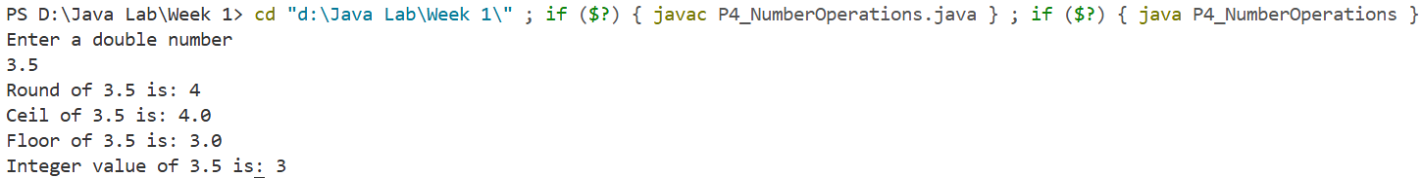
P5_MathClass
Develop a module that demonstrates the usage of various methods from the Math class in Java. The program should showcase at least five different methods (e.g., Math.abs, Math.sqrt, Math.pow, Math.sin, Math.cos).

import java.util.Scanner;
import java.lang.Math;
class P5_MathClass{
public static void main(String[] Args){
Scanner sc = new Scanner(System.in);
System.out.println("Enter number");
int num = sc.nextInt();
System.out.println("abs of "+num+" is: "+Math.abs(num));
System.out.println("sqrt of "+num+" is: "+Math.sqrt(num));
System.out.println(num+"^2 is: "+Math.pow(num,2));
System.out.println("Sine value of "+num+" is: "+Math.sin(num));
System.out.println("Cosine value of "+num+" is: "+Math.cos(num));
}
}
Output:
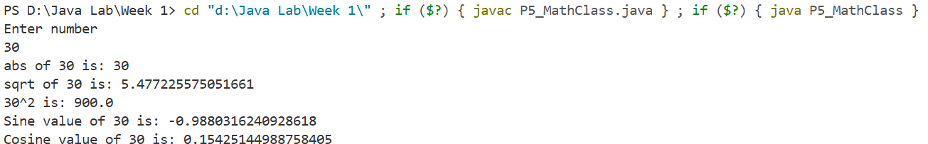

Week 2
P1_EvenOddCounter
You are working on a module for a school project that counts the number of odd and even numbers entered by students during a math quiz.

import java.util.Scanner;
class P1_EvenOddCounter{
public static void main(String[] args){
Scanner sc = new Scanner(System.in);
System.out.println("Enter size of array: ");
int size = sc.nextInt();
if(size<0){
System.out.println("size cant be negative.");
}else{
int arr[] =new int[size];

System.out.println("Enter numbers: ");
for(int i=0;i<size;i++){
arr[i]=sc.nextInt();
}
int even=0,odd=0;
for(int i=0;i<size;i++){
if(arr[i]%2==0){
even++;
}else{
odd++;
}
}

System.out.println("Number of Even is: "+even);
System.out.println("Number of Odd is: "+odd);
}
}
}
Output:
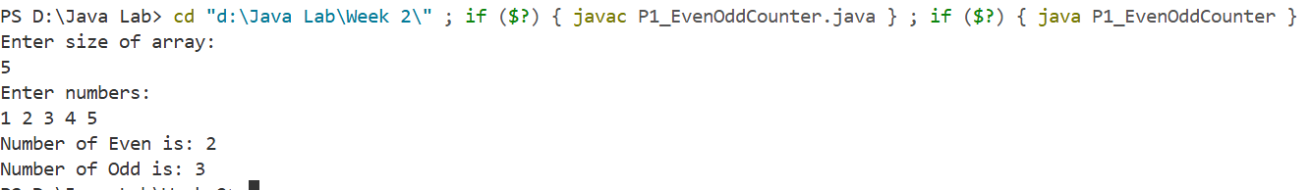
P2_SquareCube
You need to develop a module that prints the squares and cubes of numbers from 1 to 5 for a math tutorial application.

import java.util.Scanner;
class P2_SquareCube{
public static void main(String[] args) {
Scanner sc = new Scanner(System.in);

System.out.println("Enter num: ");
int num= sc.nextInt();
System.out.printf("%-10s %-10s %-10s\n","Number","Square","Cube");
for(int i=1;i<=num;i++){
System.out.printf("%-10d %-10d %-10d\n",i,i*i,i*i*i);
}
}
}
Output:
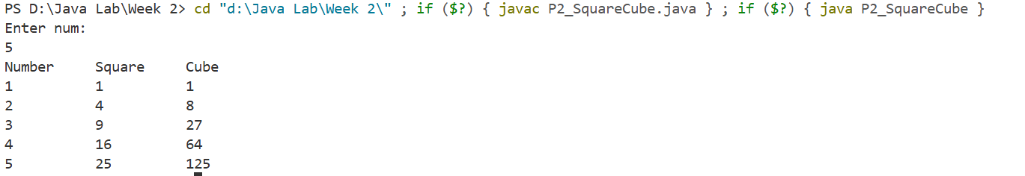

P3_ReciSum
You are tasked with writing a program to compute the sum of the reciprocals of numbers from 1 to a given number for a math research project.

import java.util.Scanner;
public class P3_ReciSum {
public static void main(String[] args) {
Scanner sc = new Scanner(System.in);

System.out.println("Enter Number");
int num = sc.nextInt();
int temp=num;
double sum=0;
if(num<0){
temp=-temp;
}
for(int i=1;i<=temp;i++){
sum+=(1/(double)i);
}
if(num<0){
sum=-sum;
}
System.out.println("Sum of recipocal of number upto "+num+" is: "+sum);
}
}
Output:
P4_EvenSum
You need to develop a module that computes the sum of even numbers up to a given number for a financial analysis tool.

import java.util.Scanner;
public class P4_EvenSum {
public static void main(String[] args) {
Scanner sc = new Scanner(System.in);
System.out.println("Enter num: ");
int num = sc.nextInt();
int sum=0;
for(int i=0;i<=num;i=i+2){
sum+=i;
}
System.out.println("Sum of even numbers upto "+num+" is: "+sum);
}
}
Output:

P5_Floyd
You are working on a module to print Floyd's triangle for a math visualization tool. Additionally, you need to modify the program to print an alternating pattern of 0s and 1s.

import java.util.Scanner;
public class P5_Floyd {
public static void main(String[] args) {
Scanner sc= new Scanner(System.in);
System.out.println("Enter num: ");
int num= sc.nextInt();

int a=1;
for(int i=1;i<=num;i++){
for(int j=1;j<=i;j++){
System.out.print(a+" ");
a++;
}
System.out.println();
}
int b=1;
for(int i=1;i<=num;i++){
for(int j=1;j<=i;j++){
System.out.print(b%2+" ");
b++;
}
System.out.println();
if(i%2==1){
b=0;
}else{
b=1;
}
}
}
}
Output:
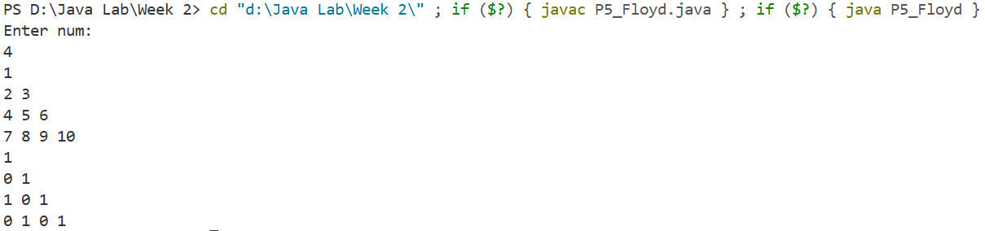

Week 3
P1_Fibonacci
You are tasked with developing a simple Java application that performs basic arithmetic operations and uses control flow statements to handle different scenarios.

import java.util.Scanner;
public class P1_Fibonacci{
public static void main(String[] args) {
Scanner sc = new Scanner(System.in);
System.out.println("Enter number: ");
int num = sc.nextInt();
int a=0, b=1;
int i=0;
if(num>0){
do {
System.out.print(a+" ");
int c=a+b;
a=b;
b=c;
i++;
} while (i<num);
}else{
System.out.println("number should be greater than 0");
}
}
}
Output:
P2_DigitCombination
You need to develop a module that accepts three digits and prints all possible combinations of these digits for a lottery system.

import java.util.Scanner;
public class P2_DigitCombination {
public static void main(String[] args) {
Scanner sc = new Scanner(System.in);
System.out.println("Enter a three digits ");
int arr[] = new int[3];
for(int i=0;i<3;i++){
arr[i] = sc.nextInt();
}
for(int i=0;i<3;i++){
for(int j=0;j<3;j++){
for(int k=0;k<3;k++){
if(i!=j && j!=k && k!=i){

System.out.println(arr[i]+""+arr[j]+""+arr[k]);
}
}
}
}

}
}
Output:
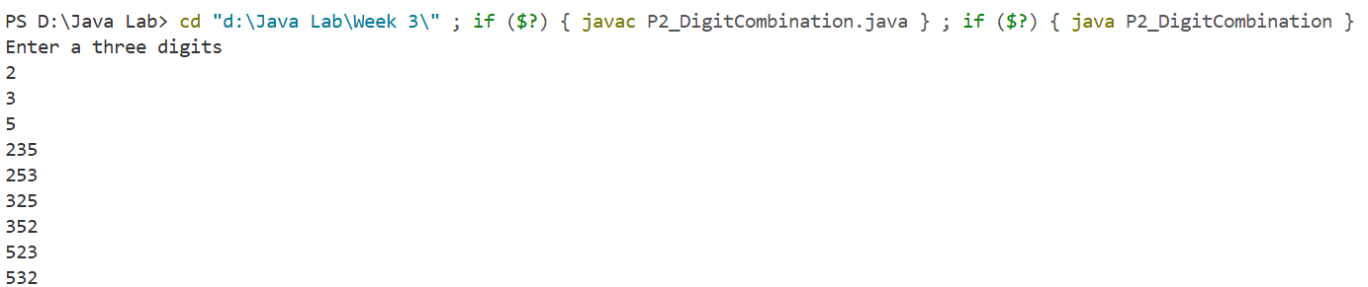

P3_SumPro
You are tasked with writing a program that prompts the user to enter 4 numbers, then computes and displays their sum and product for a financial analysis tool.

import java.util.Scanner;
class P3_SumPro{
public static void main(String[] args) {
Scanner sc = new Scanner(System.in);
System.out.println("Enter Four Numbers");
double arr[] = new double[4];
for(int i=0;i<arr.length;i++){
arr[i]= sc.nextDouble();
}
double sum=0,product=1;
for(int i=0;i<arr.length;i++){
sum+=arr[i];
product*=arr[i];
}
System.out.println("Product is: "+product+"\nSum is: "+sum);
}
}
Output:
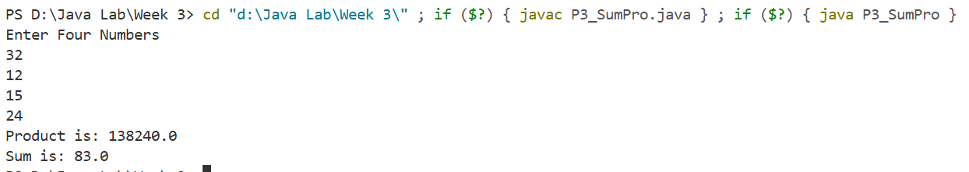
P4_DigitSeparator
You need to develop a module that reads a 4-digit number and prints the digits on separate lines for a data entry application.

import java.util.Scanner;
public class P4_DigitSeparator {
public static void main(String[] args) {
Scanner sc = new Scanner(System.in);

System.out.println("Enter a four digit integer number: ");
int num = sc.nextInt();
System.out.print("digits of "+num+" is: ");
int temp =num;
while(temp>0){
System.out.print(temp%10+", ");
temp=temp/10;
}
}
}
Output:

P5_RectangleIntersection
You are working on a module for a graphics application that computes the intersection of two rectangles. The program should handle cases where rectangles do not overlap.

import java.util.Scanner;
public class P5_RectangleIntersection {
public static void main(String[] args) {
Scanner sc = new Scanner(System.in);
System.out.println("Enter bottom left coordinates,width & height of rectangle 1: ");
int x1 = sc.nextInt();
int y1 = sc.nextInt();
int width1 =sc.nextInt();
int height1 = sc.nextInt();
int x2 = x1+width1;
int y2 = y1+height1;
System.out.println("Enter bottom left coordinates,width & height of rectangle 2: ");
int a1 = sc.nextInt();
int b1 = sc.nextInt();
int width2 =sc.nextInt();
int height2 = sc.nextInt();
int a2= a1+width2;
int b2= b1+height2;
if(x1<a1 && a1<x2 && y1<b1 && b1< y2){
System.out.println("Bottom left coordinates,width & height is :"+a1+" "+b1+" "+(x2-a1)+" "+(y2-b1));
}else if (a1<x1 && x1<a2 && y1<b1 && b1<y2) {
System.out.println("Bottom left coordinates,width & height is :"+x1+" "+b1+" "+(b1-y1)+" "+(y2-b1));
}else if(a1<x1 && x1<a2 && b1<y1 && y1<b2){
System.out.println("Bottom left coordinates,width & height is :"+x1+" "+y1+" "+(b1-y1)+" "+(b2-y1));
}else if (a1<x2 && x2<a2 && b1<y1 && y1<b2) {
System.out.println("Bottom left coordinates,width & height is :"+a1+" "+y1+" "+(x2-a1)+" "+(b2-y1));
}else if (x1<a1 && a2<x2 && y1<b1 && b2<y2) {
System.out.println("Rectangle 2 is inside rectangle 2");
}else{
System.out.println("Rectangle do not intersects");
}

}
}
Output:
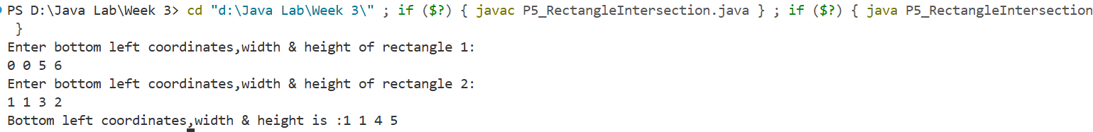

Week 4
P1_OddEvenCounter
You are working on a module for a school project that counts the number of odd and even numbers entered by students during a math quiz. The module should use a class OddAndEven to manage the count and a TestOddAndEven class to test the functionality.

import java.util.Scanner;
class OddEven{
private int even = 0;
private int odd = 0;
public void checkEvenOdd(int num){
if(num%2==0){
even++;
}else{
odd++;
}
}
public int totalEven(){
return even;
}
public int totalOdd(){
return odd;
}
}
public class P1_OddEvenCounter{
public static void main(String[] args) {
Scanner sc = new Scanner(System.in);
System.out.println("enter how many number student will enter: ");
int size = sc.nextInt();
OddEven oe = new OddEven();
for(int i=0;i<size;i++){
System.out.print("Enter num "+(i+1)+": ");
int num = sc.nextInt();
oe.checkEvenOdd(num);
}
System.out.println("Total evens are: "+oe.totalEven());
System.out.println("Total odds are: "+oe.totalOdd());
sc.close();
}
}
Output:
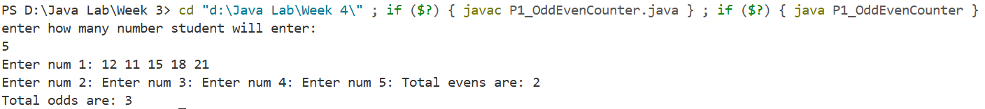

P2_Circle
You need to develop a module for a geometry application that calculates the area and perimeter of a circle. Additionally, the module should check if a given point is inside the circle.

import java.util.Scanner;
class Circle{
double area(double radius){ return (22*radius*radius)/7; }
double perimeter(double radius){ return (44*radius)/7; }
void checkPoint(double x,double y,double a,double b,double radius){
double A = (x-a)*(x-a)+(y-b)*(y-b);
Double R = radius*radius;
if(A<R){
System.out.println("point is inside the circle");
}else if(A==R){
System.out.println("Point is on cicle");
}else{
System.out.println("point is outside circle");
}}}

public class P2_Circle {
public static void main(String[] args) {
Scanner sc = new Scanner(System.in);

System.out.println("Enter radius of circle: ");
double radius = sc.nextDouble();

System.out.println("Enter coordinates(x,y) of centre of circle: ");
double x=sc.nextInt();
double y =sc.nextInt();

System.out.println("Enter coordinates(a,b) of point: ");
double a=sc.nextInt();
double b=sc.nextInt();

Circle circle = new Circle();
System.out.println("area of circle is: "+circle.area(radius));
System.out.println("Perimeter of circle is: "+circle.perimeter(radius));
circle.checkPoint(x, y, a, b, radius);
sc.close();
}}
Output:
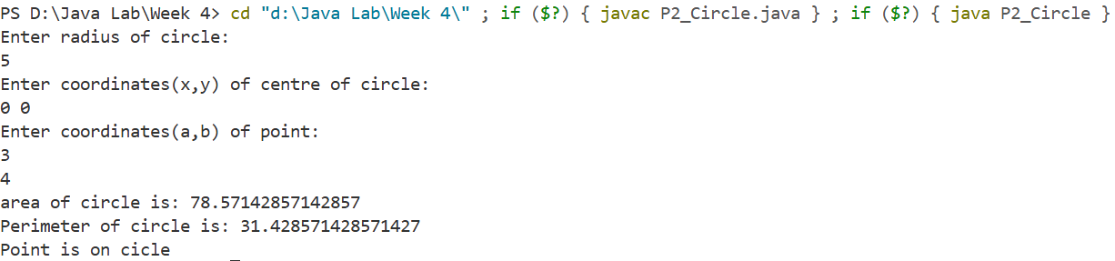
P3_TextAnalysis
You are tasked with writing a program for a text analysis tool that counts the number of words, sentences, and occurrences of specific letters in a given text.

import java.util.Scanner;
class Text{
int wordCount(String str){
String[] words = str.split(" ");
return words.length;
}
int sentenceCount(String str){
String[] sentences = str.split("\\.");
return sentences.length;

int count =0;
for(int i=0;i<str.length();i++){
if(str.charAt(i)=='.' || str.charAt(i)=='?'){
count++;
}
}
return count;
}
int occur(String str, char ch){
int count =0;
for(int i=0;i<str.length();i++){
if(str.charAt(i)==ch){
count++;
}
}
return count;
}}
public class P3_TextAnalysis {
public static void main(String[] args) {
Scanner sc = new Scanner(System.in);
System.out.println("enter text: ");
String text = sc.nextLine();

System.out.println("Enter character: ");
char ch = sc.next().charAt(0);
Text t = new Text();
System.out.println("no. of words: "+t.wordCount(text));
System.out.println("no. of sentences: "+t.sentenceCount(text));
System.out.println("Number of '"+ch+"': "+t.occur(text, ch));
sc.close();
}
}
Output:
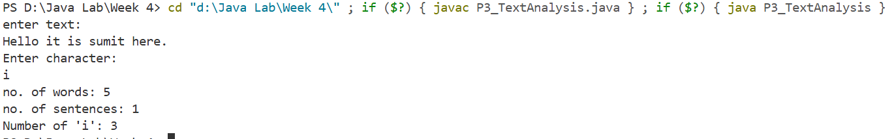
P4_SalesComision
You need to develop a module for a sales management application that calculates the commission based on sales figures. The commission rates are as follows:
● Under 500: 2% of sales
● Between 500 and 5000: 5% of sales
● 5000 and above: 8% of sales

import java.util.Scanner;
public class P4_SalesComision{
public static void main(String[] args) {
Scanner sc = new Scanner(System.in);
System.out.println("enter sales: ");
double sales = sc.nextDouble();
double commision;
if (sales >= 0) {
if (sales < 500) {
commision = sales * 0.02;
} else if (sales >= 500 && sales < 5000) {
commision = sales * 0.05;
} else {
commision = sales * 0.08;
}
System.out.println("commision: " + commision);
} else {
System.out.println("invalid input");
}
sc.close();
}
}
Output:

Week 5
P1_Book
You need to design a Book class to represent individual books in the library. The class should include attributes such as book ID, title, author, genre, and availability status. Implement appropriate methods, including getters and setters

public class P1_Book {
private int bookId;
private String title;
private String author;
private String genre;
private boolean isAvailable;

public P1_Book() {
}

public P1_Book(int bookId, String title, String author, String genre, boolean isAvailable) {
this.bookId = bookId;
this.title = title;
this.author = author;
this.genre = genre;
this.isAvailable = isAvailable;
}
public void setBookDetails(int bookId, String title, String author, String genre, boolean isAvailable) {
this.bookId = bookId;
this.title = title;
this.author = author;
this.genre = genre;
this.isAvailable = isAvailable;
}

Getter
public int getBookId() {
return bookId;
}

public String getTitle() {
return title;
}

public String getAuthor() {
return author;
}

public String getGenre() {
return genre;
}

public boolean isAvailable() {
return isAvailable;
}

setter
public void setBookId(int bookId) {
this.bookId = bookId;
}

public void setTitle(String title) {
this.title = title;
}

public void setAuthor(String author) {
this.author = author;
}

public void setGenre(String genre) {
this.genre = genre;
}

public void setAvailable(boolean available) {
isAvailable = available;
}

public void displayBookInfo() {
System.out.println("Book ID: " + bookId);
System.out.println("Title: " + title);
System.out.println("Author: " + author);
System.out.println("Genre: " + genre);
System.out.println("Available: " + (isAvailable ? "Yes" : "No"));
}
public static void main(String[] args) {
P1_Book book = new P1_Book(1, "Java Basics", "John Doe", "Programming", true);
book.displayBookInfo();
}
}
Output:
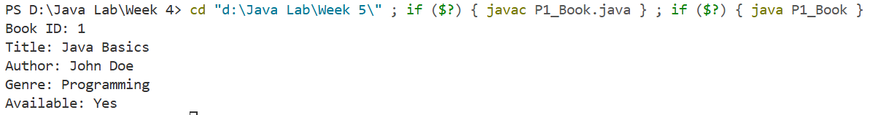

P2_User
You need to design a User class to represent library users. The class should include attributes such as user ID, name, and
a list to store borrowed books. Implement methods to borrow and return books.

import java.util.ArrayList;
public class P2_User {
private int userId;
private String name;
private ArrayList<Integer> borrowedBooks;
public P2_User(int userId,String name){
this.userId=userId;
this.name=name;
this.borrowedBooks = new ArrayList<>();
}
public void borrowBook(int bookId){
borrowedBooks.add(bookId);
}
public void returnBook(int bookId){
if(!borrowedBooks.contains(bookId)){
System.out.println("Book ID "+bookId+" was not borrowed.");
} else {
borrowedBooks.remove(Integer.valueOf(bookId));
System.out.println("Book ID "+bookId+" returned successfully.");
} }
public void displayUser(){
System.out.println("User ID: "+userId);
System.out.println("Name: "+name);
System.out.println("Borrowed Books: "+borrowedBooks);
}
public static void main(String[] args) {
P2_User user = new P2_User(1, "Alice");
user.borrowBook(101);
user.borrowBook(102);
user.displayUser();
user.returnBook(101);
user.displayUser();
user.returnBook(102);
user.displayUser();
user.returnBook(103);
user.displayUser();
}}
Output:
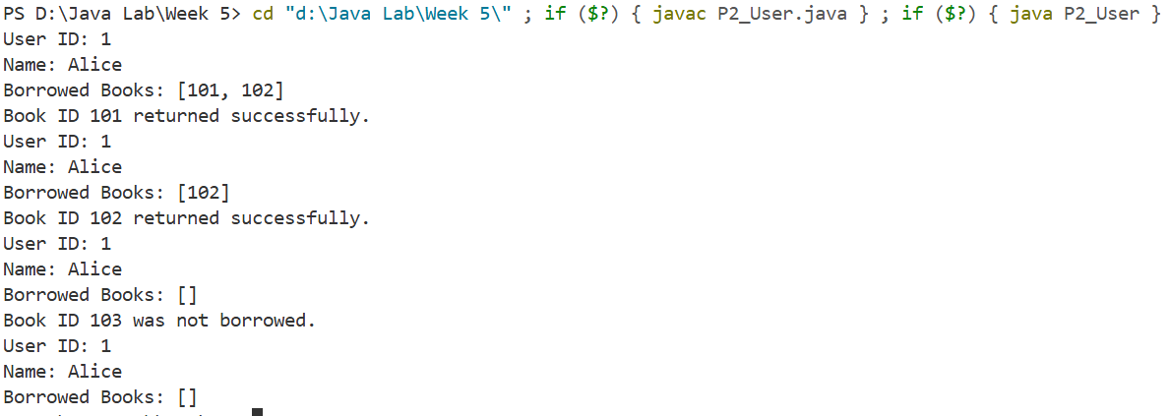
P3_Catalog
You need to design a Catalog class to represent the library catalog. The class should use collections (e.g., ArrayList) to store a collection of books. Implement methods to add books to the catalog, display available books, and update book status

import java.util.ArrayList;
public class P3_Catalog {
private ArrayList<P1_Book> books;
P3_Catalog(){
this.books = new ArrayList<>();
}
public void add(P1_Book book){
books.add(book);
}
public void dispayAvailableBooks(){
System.out.println("Available Books: ");
for(int i=0;i<books.size();i++){
System.out.println("Book ID: " + books.get(i).getBookId());
System.out.println("Title: " + books.get(i).getTitle());
System.out.println("Author: " + books.get(i).getAuthor());
System.out.println("Genre: " + books.get(i).getGenre());
System.out.println("Available: " + books.get(i).isAvailable());
}}
public void updateBookStatus(int bookId,boolean availability){
for(int i=0;i<books.size();i++){
if(books.get(i).getBookId()==bookId){
books.get(i).setAvailable(availability);
}}}
public static void main(String[] args) {
P3_Catalog catalog = new P3_Catalog();
P1_Book book1 = new P1_Book(1, "Java Basics", "John Doe", "Programming", true);
P1_Book book2 = new P1_Book(2, "Advanced Java", "Jane Smith", "Programming", false);
catalog.add(book1);
catalog.add(book2);
catalog.dispayAvailableBooks();
System.out.println();
catalog.updateBookStatus(1, false);
catalog.dispayAvailableBooks();
}}
Output:
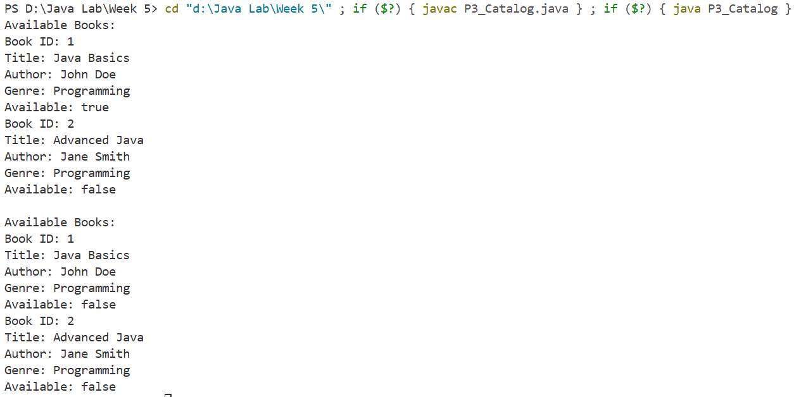
P4_Error
Ensure that proper encapsulation is applied to protect the internal state of the Book and User classes. Use access modifiers to restrict direct access to attributes.

public class P4_Error {
public static void main(String[] args) {
P1_Book book1 = new P1_Book(1, "Java Basics", "John Doe", "Programming", true);
P2_User user1 = new P2_User(1, "Bari jii");
try {
System.out.println(book1.author);
} catch (Exception e) {
System.out.println("Error is: "+e);
}
try {
System.out.println(user1.name);
} catch (Exception e) {
System.out.println("Error is: "+e);
}
}
}
Output:
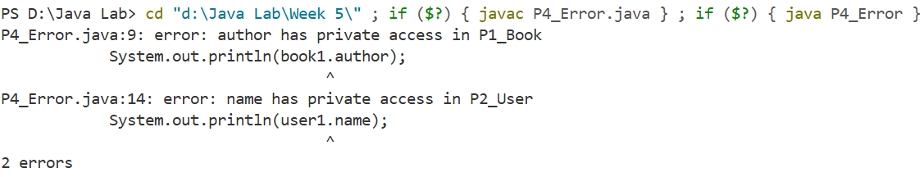
P5_SpecificBook
Utilize inheritance to create a more specific type of book (e.g., FictionBook, NonFictionBook) that extends the base Book class. Demonstrate polymorphism through a method like displayDetails() that can provide different information basedon the book type.

enum BookType {Fiction,NonFiction};
public class P5_SpecificBook extends P1_Book {
private BookType bookType;

P5_SpecificBook(int bookId,String title, String author,String genre, boolean isAvailable, BookType bt){
super(bookId, title, author, genre, isAvailable);
this.bookType=bt;
}

P5_SpecificBook(){}
public void setBookDetails(int bookId, String title, String author, String genre, boolean isAvailable, BookType bt) {
super.setBookDetails(bookId, title, author, genre, isAvailable);
this.bookType =bt;
}

BookType getBookType(){
return bookType;
}
void setBookType(BookType bt){
this.bookType = bt;
}
public void displayBookInfo() {
System.out.println("Book ID: " + getBookId());
System.out.println("Book Type: "+ bookType);
System.out.println("Title: " + getTitle());
System.out.println("Author: " + getAuthor());
System.out.println("Genre: " + getGenre());
System.out.println("Available: " + (isAvailable() ? "Yes" : "No"));
}
public static void main(String[] args) {
P5_SpecificBook book1 = new P5_SpecificBook(1, "Fiction Book", "Fiction Author", "Fiction", true, BookType.Fiction);
P5_SpecificBook book2 = new P5_SpecificBook(2, "Non-Fiction Book", "Non-Fiction Author", "Non-Fiction", true, BookType.NonFiction);

book1.displayBookInfo();
System.out.println();
book2.displayBookInfo();

P5_SpecificBook book3 = new P5_SpecificBook();
book3.setBookDetails(3, "Fiction Book3", "Fiction Author3", "Fiction", true, BookType.Fiction);
book3.displayBookInfo();
System.out.println("");

P5_SpecificBook book4 = new P5_SpecificBook();
book4.setBookDetails(4, "Fiction Book4", "Fiction Author4", "Fiction", true, BookType.Fiction);
book4.displayBookInfo();

}
}

Output:
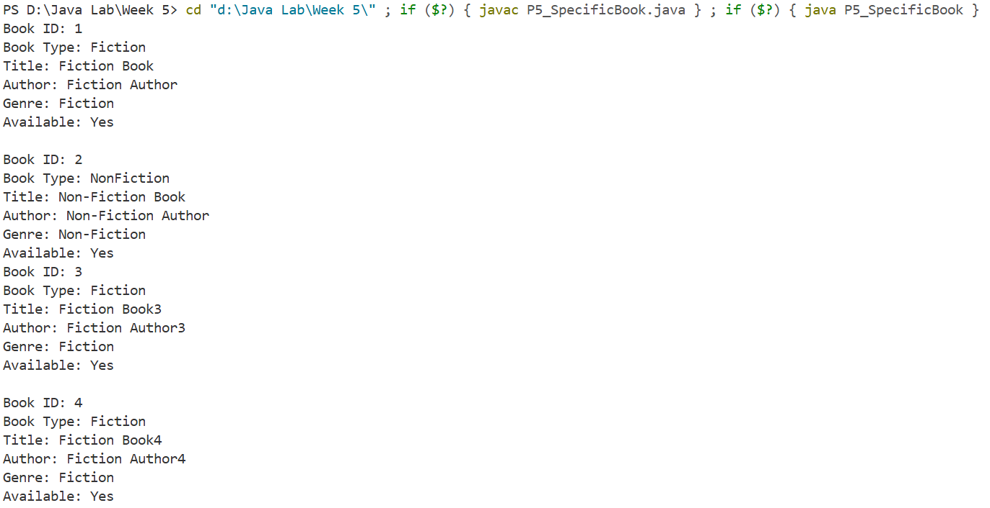

P6_Main
In the main program, instantiate the classes, add books to the catalog, create users, and simulate the borrowing and returning of books. Display the catalog's status aftereach operation.

import java.util.Scanner;
public class P6_Main {
public static void main(String[] args) {
Scanner sc = new Scanner(System.in);

P3_Catalog catalog = new P3_Catalog();
P1_Book book1 = new P1_Book(1, "Java Basics", "John Doe", "Programming", true);
P1_Book book2 = new P1_Book(2, "Advanced Java", "Jane Smith", "Programming", true);
catalog.add(book1);
catalog.add(book2);
P2_User user = new P2_User(1, "Alice");
user.displayUser();

System.out.println("Initial Catalog:");
catalog.dispayAvailableBooks();
System.out.println("\nAlice borrows Book ID 1:");
user.borrowBook(1);
catalog.updateBookStatus(1, false);
catalog.dispayAvailableBooks();
user.displayUser();
sc.close();
}}
Output:
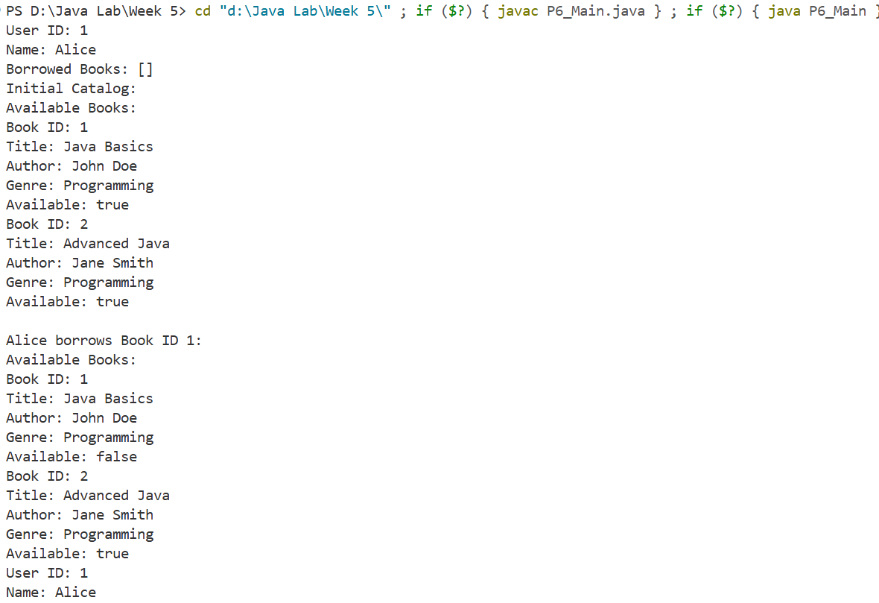
Week 6
P1_TextReversal
You are working on a text processing module for a language learning application. The module should read a sentence from the user and print it out with each word reversed, but with the words and punctuation in the original order.

import java.util.Scanner;
public class P1_TextReversal {
public static void main(String[] args) {
Scanner sc = new Scanner(System.in);
System.out.println("Enter Sentence");
String sentence = sc.nextLine();
String words[] = sentence.split(" ");

for(String word : words){
for(int i=word.length()-1;i>=0;i--){
System.out.print(word.charAt(i));
}
System.out.print(" ");
}
}
}
Output:
P2_Interface
You need to develop a module for a software design tool that supports multiple inheritances using interfaces. Implement a standalone Java program that demonstrates this concept.

interface A{
default void methodA(){
System.out.println("Method of Interface A");
}
}
interface B{
void methodB();
}
public class P2_Interface implements A,B {
@Override
public void methodB(){
System.out.println("Method of interface B from class P2_Interface");
}
public static void main(String[] args) {
P2_Interface obj = new P2_Interface();

obj.methodA();
obj.methodB();
}
}
Output:
P3_lexicology
You are working on a module for a text analysis tool that reads three strings and sorts them lexicographically.

import java.util.Arrays;
import java.util.Scanner;
public class P3_lexicology {
public static void main(String[] args) {
Scanner sc = new Scanner(System.in);
String str[] = new String[3];
System.out.println("Enter 3 strings: ");
for (int i = 0; i < str.length; i++) {
str[i] = sc.next();
}
Arrays.sort(str);
System.out.println("\nSorted STR is: ");
for (String word : str) {
System.out.println(word);
}
}
}
Output:
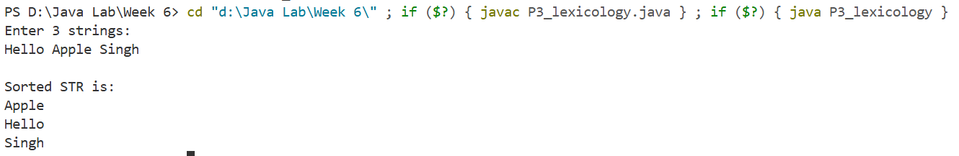
P4_ShapeMgmt
You need to develop a module for a graphics application that manages different shapes using an interface. Implement classes for shapes (e.g., Circle, Rectangle, Triangle) and use an interface for common methods like draw() and getArea().

interface Shape{
void show();
double getArea();
}
class Circle implements Shape{
private double radius;

public Circle(double radius) {
this.radius=radius;
}

public void show(){
System.out.println("Drawing circle with radius: "+radius);
}
public double getArea(){
return Math.PI*radius*radius;
}
}
class Rectangle implements Shape{
private double length;
private double breath;

public Rectangle(double length,double breath) {
this.breath=breath;
this.length=length;
}

public void show(){
System.out.println("Drawing recatngle with length: "+length+" breath: "+breath);
}
public double getArea(){
return length*breath;
}
}
class Triangle implements Shape{
private double height;
private double base;

public Triangle(double height,double base) {
this.base=base;
this.height=height;
}

public void show(){
System.out.println("Drawing triangle with height: "+height+" base: "+base);
}
public double getArea(){
return 0.5*height*base;
}
}
public class P4_ShapeMgmt {
public static void main(String[] args) {
Shape circle = new Circle(5);
circle.show();
System.out.println("Area of circle is: "+circle.getArea()+"\n");

Rectangle rect = new Rectangle(5, 4);
rect.show();
System.out.println("Area of Rectanle is: "+rect.getArea()+"\n");

Triangle tri = new Triangle(5, 4);
tri.show();
System.out.println("Area of Triangle is: "+tri.getArea()+"\n");
}
}
Output:
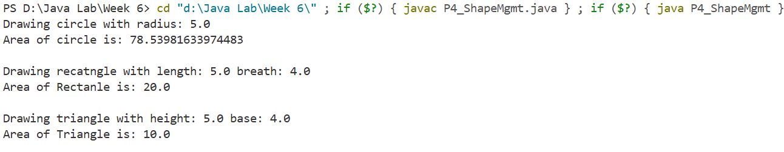

Week 7
P1_DataProcessor
You are working on a data processing module for a financial analysis tool. Themodule should read numeric values from a text file, calculate the average of these values, and output the result to another text file. The program should handle filerelated issues and invalid data using exception handling.

import java.io.*;
import java.util.*;
class InvalidDataException extends Exception {
public InvalidDataException(String message) {
super(message);
}
}
public class P1_DataProcessor {
public static List<Double> readFile(String fileName)
throws FileNotFoundException, IOException, InvalidDataException, IllegalArgumentException {
BufferedReader br = new BufferedReader(new FileReader(fileName));
String line;
List<Double> arr = new ArrayList<>();
while ((line = br.readLine()) != null) {
String[] numbers = line.trim().split("\\s+");
for (String number : numbers) {
if (!number.isEmpty()) {
try {
arr.add(Double.parseDouble(number));
} catch (NumberFormatException e) {
throw new InvalidDataException("\"" + number + "\" is not a valid number.");
}
}
}
}
br.close();
if (arr.isEmpty()) {
throw new IllegalArgumentException("No numeric values found in the file.");
}
return arr;
}

public static double calculateAverage(List<Double> arr) {
double sum = 0;
for (double number : arr) {
sum += number;
}
return sum / arr.size();
}

public static void writeFile(String fileName, double avg)
throws IOException {
BufferedWriter bw = new BufferedWriter(new FileWriter(fileName));
bw.write("Average: " + avg);
bw.close();
}

public static void main(String[] args) {
String inputFile = "input.txt";
String outputFile = "output.txt";
try {
List<Double> arr = readFile(inputFile);
double avg = calculateAverage(arr);
writeFile(outputFile, avg);
System.out.println("File written successfully.");
}
catch (FileNotFoundException e) {
System.out.println(e);
}
catch (InvalidDataException e) {
System.out.println(e);
}
catch (IllegalArgumentException e) {
System.out.println(e);
}
catch (IOException e) {
System.out.println(e);
}
}
}
Output:
Input.txt
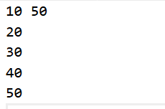
Output.txt
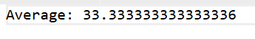

P2_DataValidation
You need to develop a module for a data validation tool that reads numeric values from a text file and validates them. Invalid data should be handled using a custom exception

import java.io.*;
import java.util.*;
public class P2_DataValidation {
public static void main(String[] args) {
String inputFile = "input.txt";
try {
BufferedReader br = new BufferedReader(new FileReader(inputFile));
String line;
List<Double> arr = new ArrayList<>();
while ((line = br.readLine()) != null) {
String[] numbers = line.trim().split("\\s+");
for (String number : numbers) {
try {
arr.add(Double.parseDouble(number));
} catch (NumberFormatException e) {
System.out.println(e);
}
}
}
br.close();
if (arr.isEmpty()) {
throw new IllegalArgumentException("No numeric values found in the file.");
}
System.out.println("Valid values: " + arr);
}
catch (FileNotFoundException e) {
System.out.println(e);
}
catch (IllegalArgumentException e) {
System.out.println(e);
}
catch (IOException e) {
System.out.println(e);
}
}
}
Output:
P3_AverageCalculation
You are tasked with writing a module for a statistical analysis tool that calculates the average of valid numeric values read from a text file.

import java.io.*;
import java.util.*;
public class P3_AverageCalculation {
public static void main(String[] args) {
String inputFile = "input.txt";
try {
BufferedReader br = new BufferedReader(new FileReader(inputFile));
String line;
List<Double> arr = new ArrayList<>();
while ((line = br.readLine()) != null) {
String[] numbers = line.trim().split("\\s+");
for (String number : numbers) {
try {
arr.add(Double.parseDouble(number));
} catch (NumberFormatException e) {
System.out.println(e);
}}}
br.close();
if (arr.isEmpty()) {
throw new IllegalArgumentException("No numeric values found in the file.");
}
double sum = 0;
for (double number : arr) {
sum += number;
}
double avg = sum / arr.size();
System.out.println("Average: " + avg);
}
catch (FileNotFoundException e) {
System.out.println(e);
}
catch (IllegalArgumentException e) {
System.out.println(e);
}
catch (IOException e) {
System.out.println(e);
}}}
Output:
Input.txt
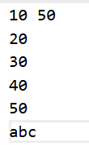
P4_FileOutput
You need to develop a module for a data reporting tool that writes the calculated average of numeric values to another text file. The module should handle file writing exceptions.

import java.io.*;
import java.util.*;
public class P4_FileOutput {
public static void main(String[] args) {
String inputFile = "input.txt";
String outputFile = "output.txt";
try {
BufferedReader br = new BufferedReader(new FileReader(inputFile));
String line;
List<Double> arr = new ArrayList<>();
while ((line = br.readLine()) != null) {
String[] numbers = line.trim().split("\\s+");
for (String number : numbers) {
try {
arr.add(Double.parseDouble(number));
} catch (NumberFormatException e) {
System.out.println(e);
}}}
br.close();
if (arr.isEmpty()) {
throw new IllegalArgumentException("No numeric values found in the file.");
}
double sum = 0;
for (double number : arr) {
sum += number;
}
double avg = sum / arr.size();
BufferedWriter bw = new BufferedWriter(new FileWriter(outputFile));
bw.write("Average: " + avg);
bw.close();
System.out.println("File written successfully.");
}
catch (FileNotFoundException e) {
System.out.println(e);
}
catch (IllegalArgumentException e) {
System.out.println(e);
}
catch (IOException e) {
System.out.println(e);
}}}
Output:
Output.txt
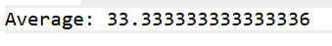

P5_MainProgram
In the main program, instantiate the DataProcessor class, call the methods in sequence to read values, validate data, calculate the average, and write the result toanother file. Handle any exceptions that occur during the process.

import java.io.*;
import java.util.*;
public class P5_MainProgram {
public static void main(String[] args) {
String inputFile = "input.txt";
String outputFile = "output.txt";
try {
List<Double> arr = P1_DataProcessor.readFile(inputFile);
double avg = P1_DataProcessor.calculateAverage(arr);
P1_DataProcessor.writeFile(outputFile, avg);
System.out.println("File written successfully.");
}
catch (FileNotFoundException e) {
System.out.println(e);
}
catch (InvalidDataException e) {
System.out.println(e);
}
catch (IllegalArgumentException e) {
System.out.println(e);
}
catch (IOException e) {
System.out.println(e);
}
}
}
Output:
Input.txt

Output.txt

P6_ComprehensiveExceptionHandling
You are tasked with developing a comprehensive exception handling module for a data processing application. The module should handle various exceptions,including file not found, invalid data, and I/O errors, and provide meaningful feedback to the user.

import java.io.*;
import java.util.*;
public class P6_ComprehensiveExceptionHandling {
public static void main(String[] args){
String inputFile = "input.txt";
String outputFile = "output.txt";
try {
List<Double> arr = P1_DataProcessor.readFile(inputFile);
double avg = P1_DataProcessor.calculateAverage(arr);
P1_DataProcessor.writeFile(outputFile, avg);
System.out.println("File written successfully.");
}
catch (FileNotFoundException e){
System.out.println(e);
}
catch (InvalidDataException e){
System.out.println(e);
}
catch (IllegalArgumentException e) {
System.out.println(e);
}
catch (IOException e) {
System.out.println(e);
}
}
}
Output:
Input.txt

Output.txt


Week 8
Problem 1: ExceptionCounter
// You are working on a module for a code analysis tool that counts the total number of exceptions in a given Java program file. The tool // should read the specified Java file, analyze its content, and count occurrences of exception-related keywords or patterns.

import java.io.*;
public class P1_ExceptionCounter{
public static void main(String[] args) {
int count = 0;
String fileName = "Hello.java";
try {
BufferedReader bReader = new BufferedReader(new FileReader(fileName));
String line;
while((line = bReader.readLine())!=null){
String[] words = line.split(" ");
for(String word: words){
if(word.contains("Exception")){
count++;
}
}
}
bReader.close();
System.out.println("Exception word occured: "+count+" times.");
} catch (Exception e) {
System.out.println(e.getMessage());
}
}
}
Output:
Problem 2: NullPointerException
// You need to develop a module for a debugging tool that identifies, handles, or prevents Null Pointer
// Exceptions in a Java program. Implement three different versions of the program using the provided
// blocks of code to demonstrate different approaches to handling Null Pointer Exceptions.

public class P2_NullPointerException {
public static void main(String[] args) {
String str = null;
try {
System.out.println(str.length());

if(str!=null){ System.out.println(str.length()); }
}
// catch (NullPointerException e) {
// System.out.println("Exception: "+e);
// }
catch(NullPointerException e){
System.out.println("caught null pointer exception");
}
}
}
Output:
Problem 3: ExceptionalHandling
// You are tasked with writing a module for a financial application that handles severe runtime exceptions
// gracefully. The module should log the exception details and provide meaningful feedback to the user.

import java.util.logging.Logger;
public class P3_ExceptionalHandling {
public static void main(String[] args) {
Logger log = Logger.getLogger("Logs");
try {
// int result = 10/0;
// System.out.println("Result: "+result);

int[] array = new int[5];
System.out.println(array[5]);

// String str = null;
// System.out.println(str.length());
} catch (ArithmeticException e) {
System.out.println(e);
log.severe("Logged: ArithmeticException occurred.");
} catch (ArrayIndexOutOfBoundsException e){
System.out.println(e);
log.severe("Logged: ArrayIndexOutOfBoundsException occurred.");
} catch(NullPointerException e){
System.out.println(e);
log.severe("Logged: NullPointerException occurred.");
}
}
}
Output:
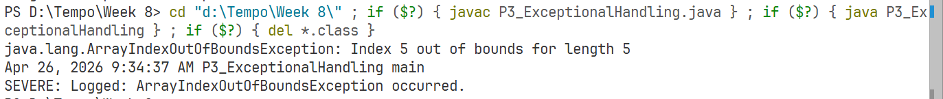
Problem 4: LoggingFramework
// You need to develop a module for a logging system that integrates a logging framework (e.g., Log4j) to log exception details.
// The module should handle exceptions gracefully and provide meaningful feedback to the user.

import java.util.logging.*;
public class P4_LoggingFramework {
public static final Logger logger = Logger.getLogger("MyLogs");
public static FileHandler fileHandler;
static {
try {
fileHandler = new FileHandler("Logs.log");
fileHandler.setFormatter(new SimpleFormatter());
logger.addHandler(fileHandler);
} catch (Exception e) {
System.out.println(e);
}
}

public static void errorFunction(int choice) {
try {

if (choice == 1) {
int result = 10 / 0;
System.out.println(result);
}
if (choice == 2) {
String str = null;
System.out.println(str.length());
}
if (choice == 3) {
int arr[] = new int[5];
System.out.println(arr[6]);
}
} catch (Exception e) {
logger.severe("Exception: " + e.getMessage() + "\n");
}
}

public static void main(String[] args) {
errorFunction(1);
errorFunction(2);
errorFunction(3);
}
}
Output:
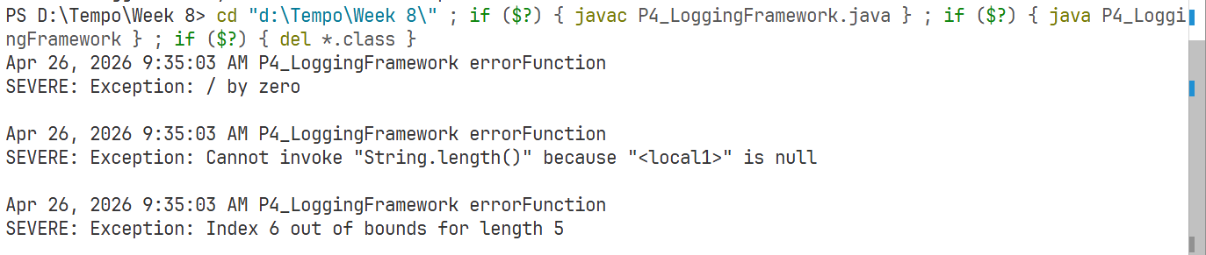
Problem 5: CustomException
// You are tasked with writing a module for a data processing application that throws a custom exception when
// encountering invalid data. The module should handle the custom exception gracefully and log the details.

import java.util.logging.Logger;
class IllegalDataException extends Exception{
IllegalDataException(String msg){
super(msg);
}
}
public class P5_CustomException {
public static void main(String[] args) {
Logger lg = Logger.getLogger("Logs");
String data = "123 abc 234";
try {
String[] arr = data.split("\\s+");
if(data==""){
throw new IllegalArgumentException("No data provided.");
}
for(String d:arr){
try {
double num = Double.parseDouble(d);
} catch (NumberFormatException e) {
throw new IllegalDataException(d+" is not a valid number.");
}
}
} catch (IllegalArgumentException e) {
lg.severe("Log: Illegal Argument Occured");
System.out.println(e);
} catch(IllegalDataException e){
lg.severe("Log: Invalid Data Exception Occured");
System.out.println(e);
} catch(Exception e){
lg.severe("Log: Error Occured");
System.out.println(e);
}
}
}
Output:
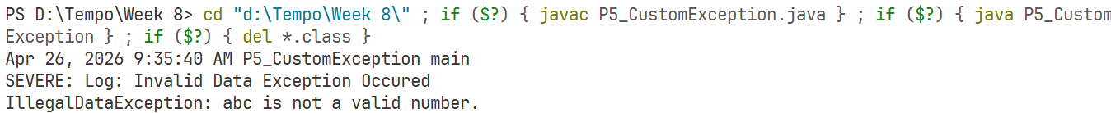
Week 9
Problem 1: UncheckedException
// You are working on a module for a file processing tool that simulates a scenario where an unchecked exception might occur. The //module should handle the exception using a try-catch block and log the details using a logging framework.

import java.util.logging.*;
public class P1_UncheckedException {
public static Logger logger = Logger.getLogger("P1_UncheckedException");
public static FileHandler fileHandler;
static{
try{
fileHandler = new FileHandler("Logs.log");
fileHandler.setFormatter(new SimpleFormatter());
logger.addHandler(fileHandler);
}catch(Exception e){
System.out.println(e);
}
}

public static void errorFunction(int choice) {
try {
if (choice == 1) {
int result = 10 / 0;
System.out.println(result);
}
if (choice == 2) {
String str = null;
System.out.println(str.length());
}
if (choice == 3) {
int arr[] = new int[5];
System.out.println(arr[6]);
}
} catch (Exception e) {
logger.severe("Exception: " + e.getMessage() + "\n");
}
}
public static void main(String[] args) {
errorFunction(1);
errorFunction(2);
errorFunction(3);
}
}
Output:
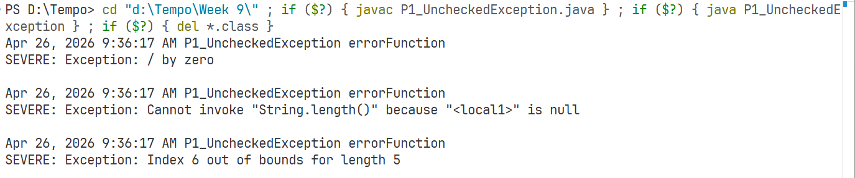
Problem 2: LoggingFramework
// You need to develop a module for a logging system that integrates a logging
// framework (e.g., Log4j) to log the details of unchecked exceptions. The module
// should handle exceptions gracefully and provide meaningful feedback to the user.

import java.util.logging.*;
public class P2_LoggingFramework {
public static Logger logger = Logger.getLogger("P1_UncheckedException");
public static FileHandler fileHandler;
static{
try{
fileHandler = new FileHandler("Logs.log");
fileHandler.setFormatter(new SimpleFormatter());
logger.addHandler(fileHandler);
}catch(Exception e){
System.out.println(e);
}
}

public static void errorFunction(int choice) {
try {

if (choice == 1) {
int result = 10 / 0;
System.out.println(result);
}
if (choice == 2) {
String str = null;
System.out.println(str.length());
}
if (choice == 3) {
int arr[] = new int[5];
System.out.println(arr[6]);
}
} catch (Exception e) {
logger.severe("Exception: " + e.getMessage() + "\n");
}
}
public static void main(String[] args) {
errorFunction(1);
errorFunction(2);
errorFunction(3);
}
}
Output:
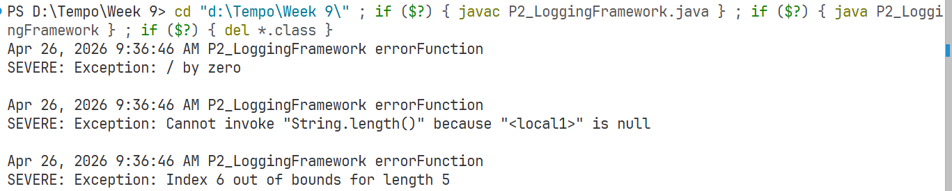
Problem 3: Termination
// You are tasked with writing a module for a file processing tool that handles severe runtime exceptions gracefully.
// The module should log the exception details and terminate the application with an error code.

import java.util.logging.*;
public class P3_Termination {
public static Logger logger = Logger.getLogger("MyLogs");
public static FileHandler fileHandler;
static{
try {
fileHandler = new FileHandler();
fileHandler.setFormatter(new SimpleFormatter());
logger.addHandler(fileHandler);
} catch (Exception e) { } }
public static void errorFunction(int choice){
try {
if (choice == 1) {
int result = 10 / 0;
System.out.println(result);
}
if (choice == 2) {
String str = null;
System.out.println(str.length());
}
if (choice == 3) {
int arr[] = new int[5];
System.out.println(arr[6]);
}
if(choice ==4){ System.out.println("No error"); }
} catch (Exception e) {
logger.severe("Exception: " + e.getMessage());
System.out.println("Application terminated with error code 1"+'\n');
}
}
public static void main(String[] args) {
errorFunction(1);
errorFunction(2);
errorFunction(3);
errorFunction(4);
}
}
Output:
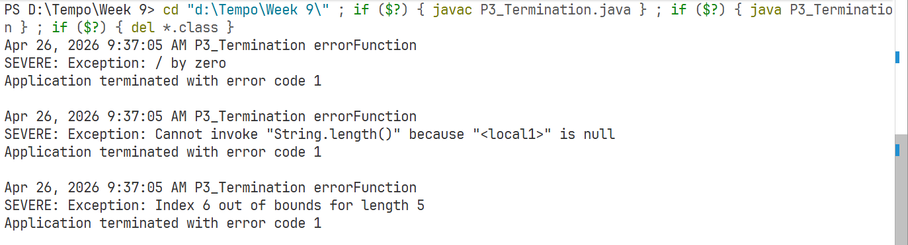
Problem 4: SevereRunExcept
// You need to develop a module for a critical system that handles severe runtime exceptions. The module should log the
// exception details and terminate the application gracefully using System.exit().

import java.util.logging.*;
public class P4_SevereRunExcept {
public static Logger logger = Logger.getLogger("MyLogs");
public static FileHandler fileHandler;
static{
try {
fileHandler = new FileHandler("Logs.log");
fileHandler.setFormatter(new SimpleFormatter());
logger.addHandler(fileHandler);
} catch (Exception e) {}}
public static void errorFunction(int choice){
try {
if (choice == 1) {
int result = 10 / 0;
System.out.println(result);
}
if (choice == 2) {
String str = null;
System.out.println(str.length());
}
if (choice == 3) {
int arr[] = new int[5];
System.out.println(arr[6]);
}
if(choice ==4){
System.out.println("No error");
}
} catch (Exception e) {
logger.severe("Exception: " + e.getMessage());
System.out.println("Application terminated with error code 1"+'\n');
System.exit(1);
}
}
public static void main(String[] args) {
try{
errorFunction(1);
errorFunction(2);
errorFunction(3);
errorFunction(4);
}catch(Exception e){
}}}
Output:
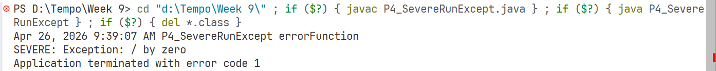
Problem 5: LogReport
// You are tasked with writing a module for a data processing tool that logs the details of unchecked exceptions using a logging
// framework. The module should handle exceptions gracefully and provide meaningful feedback to the user.

import java.util.logging.*;
public class P5_LogReport {
public static Logger logger = Logger.getLogger("MyLogs");
public static FileHandler fileHandler;
static{
try {
fileHandler = new FileHandler();
fileHandler.setFormatter(new SimpleFormatter());
logger.addHandler(fileHandler);
} catch (Exception e) {}}
public static void errorFunction(int choice){
try {

if (choice == 1) {
int result = 10 / 0;
System.out.println(result);
}
if (choice == 2) {
String str = null;
System.out.println(str.length());
}
if (choice == 3) {
int arr[] = new int[5];
System.out.println(arr[6]);
}
if(choice ==4){
System.out.println("No error");
}
} catch (Exception e) {
logger.severe("Exception: " + e.getMessage());
System.err.println();
}
}
public static void main(String[] args) {
errorFunction(1);
errorFunction(2);
errorFunction(3);
errorFunction(4);
}}
Output:
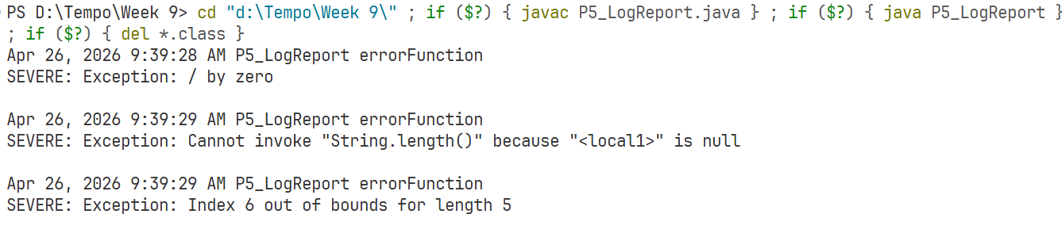
Problem 6: ComException
// You need to develop a comprehensive exception handling module for a critical system that handles various unchecked exceptions,
// logs the details, and terminates the application gracefully.

import java.util.logging.*;
public class P6_ComException {
public static Logger logger = Logger.getLogger("MyLogs");
public static FileHandler fileHandler;
static{
try {
fileHandler = new FileHandler();
fileHandler.setFormatter(new SimpleFormatter());
logger.addHandler(fileHandler);
} catch (Exception e) {
}
}
public static void errorFunction(int choice){
try {
if (choice == 1) {
int result = 10 / 0;
System.out.println(result);
}
if (choice == 2) {
String str = null;
System.out.println(str.length());
}
if (choice == 3) {
int arr[] = new int[5];
System.out.println(arr[6]);
}
if(choice ==4){
System.out.println("No error");
}
} catch (Exception e) {
logger.severe("Exception: " + e.getMessage());
System.out.println("Application terminated with error code 1"+'\n');
}
}
public static void main(String[] args) {
errorFunction(1);
errorFunction(2);
errorFunction(3);
errorFunction(4);
}}
Output:
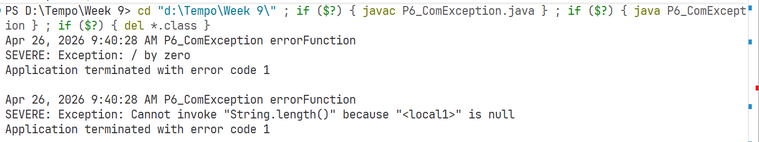
Problem 7: CustomException
// You are tasked with writing a module for a data processing application that throws a custom exception when encountering invalid
// data. The module should handle the custom exception gracefully and log the details.

import java.util.logging.*;
class InvalidDataException extends Exception{
InvalidDataException(String msg){
super(msg);
}
}
public class P7_CustomException{
public static Logger logger = Logger.getLogger("MyLogs");
public static FileHandler fileHandler;
static{
try{
fileHandler = new FileHandler("Logs.log");
fileHandler.setFormatter(new SimpleFormatter());
logger.addHandler(fileHandler);
}catch(Exception e){
System.out.println(e);
}
}
public static void readValue(String str) throws InvalidDataException,IllegalArgumentException{
String data[] = str.split("\s++");
System.out.println(data.length);
if(str.equals("")){
throw new IllegalArgumentException("No data provided.");
}
for(String i : data){
try {
System.out.println(Double.parseDouble(i));
} catch (Exception e) {
throw new InvalidDataException(i+" is not a valid number");
}
}
}
public static void main(String[] args) {
try {
readValue("");
} catch (InvalidDataException e) {
System.out.println("Exception: "+e);
logger.severe("Invalid Data Exception error occured");
} catch (IllegalArgumentException e){
System.out.println("Exception: "+e);
logger.severe("Illegal Argument Exception error occured");
}
}

}
Output:
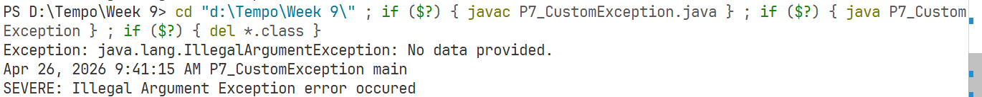
Week 10
Problem 1: DBConnection
// You are tasked with developing a Java application that manages database connections and handlees checked exceptions effectively.
// The application should use advanced techniques for exception handling and resource management.

import java.sql.*;
public class P1_DBConnection {
public static void main(String[] args) {
String url = "jdbc:mysql://localhost:3306/week10";
String user = "root";
String password = "";

try (Connection conn = DriverManager.getConnection(url,user,password)){
Class.forName("com.mysql.cj.jdbc.Driver");
System.out.println("Database Connected");

try(ResultSet rs = conn.createStatement().executeQuery("Select * from student");) {
/* Student have id,name. */

while(rs.next()){
System.out.print("Id: "+rs.getInt("id"));
System.out.println(", Name: "+rs.getString("name"));
}
} catch (Exception e) {
System.out.println("Invalid Statement");
System.out.println(e);
}
}
catch (ClassNotFoundException e) {
System.out.println("MySQL JDBC Driver not found");
System.out.println(e);
}
catch (SQLException e){
System.out.println("Invalid DB Details / DB Connection Failed.");
System.out.println(e);
}
System.out.println("DB Connection Closed");
}
}
Output:
Problem 2: CustomExceptionDB
// You need to develop a module for a database management system that introduces a custom exception class
// for representing database connection-related issues. The module should throw this custom exception instead
// of the generic SQLException when encountering database connection Problems.

import java.sql.*;
class DatabaseConnectionException extends Exception{
DatabaseConnectionException(String msg){
super(msg);
}
}
public class P2_CustomExceptionDB {
private static final String url = "jdbc:mysql://localhost:3306/week10";
private static final String user = "root";
private static final String password = "";

public static Connection getConnection(String url,String user,String password) throws DatabaseConnectionException{
try{
Connection conn = DriverManager.getConnection(url,user,password);
System.out.println("Database Connected");
return conn;
}catch(SQLException e){
throw new DatabaseConnectionException("Unable to Connect DB");
}
}
public static void executeQuery(Connection conn){
try(ResultSet rs = conn.createStatement().executeQuery("Select * from student");) {
/* Student have id,name. */
while(rs.next()){
System.out.print("Id: "+rs.getInt("id"));
System.out.println(", Name: "+rs.getString("name"));
}
} catch (Exception e) {
System.out.println("Invalid Statement");
System.out.println(e);
}
}
public static void main(String[] args) {
try(Connection conn = getConnection(url, user, password);) {
executeQuery(conn);
} catch (Exception e) {
System.out.println(e);
}

}
}
Output:
Problem 3: LoggingDB
// You are tasked with writing a module for a database management system that logs
// the details of database connection issues using a logging framework. The module
// should handle exceptions gracefully and provide meaningful feedback to the user.

import java.sql.*;
import java.util.logging.*;
class DatabaseConnectionException extends Exception {
DatabaseConnectionException(String msg) {
super(msg);
}
DatabaseConnectionException(String msg,Throwable e) {
super(msg,e);
}
}
public class P3_LoggingDB {
private static final String url = "jdbc:mysql://localhost:3306/week10";
private static final String user = "root";
private static final String password = "";
private static final Logger logger = Logger.getLogger("mylog");

static {
try {
FileHandler fileHandler = new FileHandler("db_logs.log", true);
fileHandler.setFormatter(new SimpleFormatter());
logger.addHandler(fileHandler);
// logger.setLevel(Level.ALL);
} catch (Exception e) {
System.out.println("Logger setup failed");
}
}
public static Connection getConnection(String url, String user, String password)
throws DatabaseConnectionException {
try {
Connection conn = DriverManager.getConnection(url, user, password);
logger.config("Database Connected Successfully");
return conn;
} catch (SQLException e) {
logger.log(Level.SEVERE, "Database connection failed", e);
throw new DatabaseConnectionException("Unable to Connect DB", e);
}
}
public static void executeQuery(Connection conn) {
String query = "SELECT * FROM student";
try (Statement stmt = conn.createStatement();
ResultSet rs = stmt.executeQuery(query)) {
logger.info("Query executed successfully");
while (rs.next()) {
System.out.print("Id: " + rs.getInt("id"));
System.out.println(", Name: " + rs.getString("name"));
}
} catch (SQLException e) {
logger.log(Level.WARNING, "Query execution failed", e);
System.out.println("Error executing query");
}
}
public static void main(String[] args) {
try (Connection conn = getConnection(url, user, password)) {
executeQuery(conn);
} catch (DatabaseConnectionException e) {
logger.log(Level.SEVERE, "Custom Exception Occurred", e);
System.out.println("User-friendly message: Unable to connect to database.");
} catch (SQLException e) {
logger.log(Level.SEVERE, "Unexpected SQL error", e);
}
System.out.println("Program Finished");
}
}
Output:
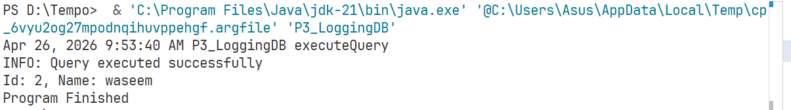
Problem 4: FinallyDB
// You need to develop a module for a database management system that uses advanced exception handling techniques,including finally
// block to log a message indicating the successful closure of the database connection, regardless of whether an exception occurred.

import java.sql.*;
import java.util.logging.*;
class DatabaseConnectionException extends Exception{
DatabaseConnectionException(String msg){super(msg);}
DatabaseConnectionException(String msg,Throwable cause){super(msg,cause);}
}
public class P4_FinallyDB{
private static final String url="jdbc:mysql://localhost:3306/week10";
private static final String user="root";
private static final String password="";
private static final Logger logger=Logger.getLogger(P4_FinallyDB.class.getName());
static{
try{
FileHandler fh=new FileHandler("db_logs.txt",true);
fh.setFormatter(new SimpleFormatter());
logger.addHandler(fh);
logger.setLevel(Level.ALL);
}catch(Exception e){System.out.println("Logger setup failed");}
}
public static Connection getConnection(String url,String user,String password)throws DatabaseConnectionException{
try{
Connection conn=DriverManager.getConnection(url,user,password);
logger.config("Database Connected");
return conn;
}catch(SQLException e){
logger.log(Level.SEVERE,"Connection Failed",e);
throw new DatabaseConnectionException("Unable to connect DB",e);
}
}
public static void executeQuery(Connection conn){
try(Statement stmt=conn.createStatement();ResultSet rs=stmt.executeQuery("SELECT * FROM student")){
while(rs.next()){
System.out.print("Id: "+rs.getInt("id"));
System.out.println(", Name: "+rs.getString("name"));
}
}catch(SQLException e){
logger.log(Level.WARNING,"Query Failed",e);
System.out.println("Error executing query");
}
}
public static void main(String[] args){
Connection conn=null;
try{
conn=getConnection(url,user,password);
executeQuery(conn);
}catch(DatabaseConnectionException e){
logger.log(Level.SEVERE,"Custom Exception",e);
System.out.println("Unable to connect to database");
}finally{
if(conn!=null){
try{
conn.close();
logger.config("Connection Closed Successfully");
}catch(SQLException e){
logger.log(Level.WARNING,"Error Closing Connection",e);
}
}
}
}
}
Output:
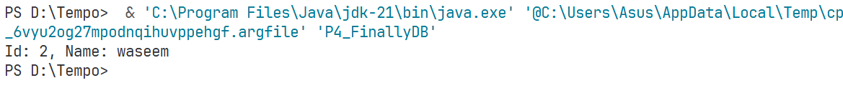
Problem 5: DBOperation
// You are tasked with writing a module for a database management system that handles checked exceptions related to
// database operations. The module should use advanced techniques for exception handling and resource management.

import java.sql.*;
import java.util.logging.*;
class DatabaseOperationException extends Exception{
DatabaseOperationException(String msg){super(msg);}
DatabaseOperationException(String msg,Throwable cause){super(msg,cause);}
}
public class P5_DBOperation{
private static final String url="jdbc:mysql://localhost:3306/week10";
private static final String user="root";
private static final String password="";
private static final Logger logger=Logger.getLogger("mylogs");
static{
try{
FileHandler fh=new FileHandler("db_logs.txt",true);
fh.setFormatter(new SimpleFormatter());
logger.addHandler(fh);
logger.setLevel(Level.ALL);
}catch(Exception e){System.out.println("Logger setup failed");}
}
public static Connection getConnection()throws DatabaseOperationException{
try{
Connection conn=DriverManager.getConnection(url,user,password);
logger.config("Database Connected");
return conn;
}catch(SQLException e){
logger.log(Level.SEVERE,"Connection Failed",e);
throw new DatabaseOperationException("Unable to connect DB",e);
}
}
public static void executeQuery(Connection conn)throws DatabaseOperationException{
String query="SELECT * FROM student";
try(PreparedStatement ps=conn.prepareStatement(query);ResultSet rs=ps.executeQuery()){
logger.info("Query Executed");
while(rs.next()){
System.out.print("Id: "+rs.getInt("id"));
System.out.println(", Name: "+rs.getString("name"));
}
}catch(SQLException e){
logger.log(Level.WARNING,"Query Failed",e);
throw new DatabaseOperationException("Error executing query",e);
}
}
public static void main(String[] args){
Connection conn=null;
try{
conn=getConnection();
executeQuery(conn);
}catch(DatabaseOperationException e){
logger.log(Level.SEVERE,"Custom Exception",e);
System.out.println("Database operation failed");
}finally{
if(conn!=null){
try{
conn.close();
logger.config("Connection Closed");
}catch(SQLException e){
logger.log(Level.WARNING,"Error Closing Connection",e);
}
}
}
}
}
Output:
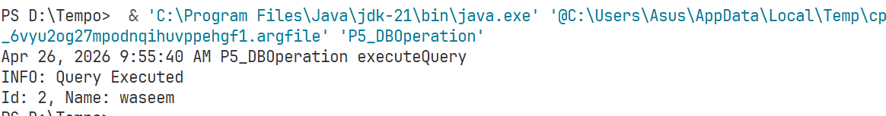
Problem 6: CustomOperationDB
// You need to develop a module for a database management system that introduces a custom exception class for representing
// database operation-related issues. The module should throw this custom exception instead of the generic SQLException
// when encountering database operation Problems.

import java.sql.*;
import java.util.logging.*;
class DatabaseOperationException extends Exception{
DatabaseOperationException(String msg){super(msg);}
DatabaseOperationException(String msg,Throwable cause){super(msg,cause);}
}
public class P6_CustomOperationDB{
private static final String url="jdbc:mysql://localhost:3306/week10";
private static final String user="root";
private static final String password="";
private static final Logger logger=Logger.getLogger(P6_CustomOperationDB.class.getName());
static{
try{
FileHandler fh=new FileHandler("db_logs.txt",true);
fh.setFormatter(new SimpleFormatter());
logger.addHandler(fh);
logger.setLevel(Level.ALL);
}catch(Exception e){System.out.println("Logger setup failed");}
}
public static Connection getConnection()throws DatabaseOperationException{
try{
Connection conn=DriverManager.getConnection(url,user,password);
logger.config("Database Connected");
return conn;
}catch(SQLException e){
logger.log(Level.SEVERE,"Connection Failed",e);
throw new DatabaseOperationException("Unable to connect DB",e);
}
}
public static void executeQuery(Connection conn)throws DatabaseOperationException{
String query="SELECT * FROM student";
try(PreparedStatement ps=conn.prepareStatement(query);ResultSet rs=ps.executeQuery()){
logger.info("Query Executed");
while(rs.next()){
System.out.print("Id: "+rs.getInt("id"));
System.out.println(", Name: "+rs.getString("name"));
}
}catch(SQLException e){
logger.log(Level.WARNING,"Query Failed",e);
throw new DatabaseOperationException("Database operation error",e);
}
}
public static void main(String[] args){
Connection conn=null;
try{
conn=getConnection();
executeQuery(conn);
}catch(DatabaseOperationException e){
logger.log(Level.SEVERE,"Custom Exception",e);
System.out.println("Database operation failed");
}finally{
if(conn!=null){
try{
conn.close();
logger.config("Connection Closed");
}catch(SQLException e){
logger.log(Level.WARNING,"Error Closing Connection",e);
}
}
}
}
}
Output:
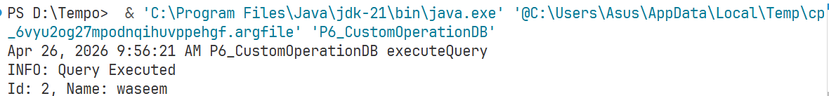
Problem 7: ComprehensiveDB
// You are tasked with writing a comprehensive exception handling module for a database management system that handles
// various checked exceptions, logs the details, and ensures proper closure of database connections.

import java.sql.*;
import java.util.logging.*;

class DatabaseException extends Exception{
DatabaseException(String msg){super(msg);}
DatabaseException(String msg,Throwable cause){super(msg,cause);}
}
public class P7_ComprehensiveDB{
private static final String url="jdbc:mysql://localhost:3306/week10";
private static final String user="root";
private static final String password="";
private static final Logger logger=Logger.getLogger(P7_ComprehensiveDB.class.getName());
static{
try{
FileHandler fh=new FileHandler("db_logs.txt",true);
fh.setFormatter(new SimpleFormatter());
logger.addHandler(fh);
logger.setLevel(Level.ALL);
}catch(Exception e){System.out.println("Logger setup failed");}
}
public static Connection getConnection()throws DatabaseException{
try{
Connection conn=DriverManager.getConnection(url,user,password);
logger.info("Database Connected");
return conn;
}catch(SQLException e){
logger.log(Level.SEVERE,"Connection Failed",e);
throw new DatabaseException("Unable to connect DB",e);
}
}
public static void executeQuery(Connection conn)throws DatabaseException{
String query="SELECT * FROM student";
try(PreparedStatement ps=conn.prepareStatement(query);ResultSet rs=ps.executeQuery()){
logger.info("Query Executed");
while(rs.next()){
System.out.print("Id: "+rs.getInt("id"));
System.out.println(", Name: "+rs.getString("name"));
}
}catch(SQLException e){
logger.log(Level.WARNING,"Query Failed",e);
throw new DatabaseException("Error executing query",e);
}
}
public static void main(String[] args){
Connection conn=null;
try{
conn=getConnection();
executeQuery(conn);
}catch(DatabaseException e){
logger.log(Level.SEVERE,"Custom Exception",e);
System.out.println("Database operation failed");
}finally{
if(conn!=null){
try{
conn.close();
logger.info("Connection Closed");
}catch(SQLException e){
logger.log(Level.WARNING,"Error Closing Connection",e);
}
}
}
}
}
Output:
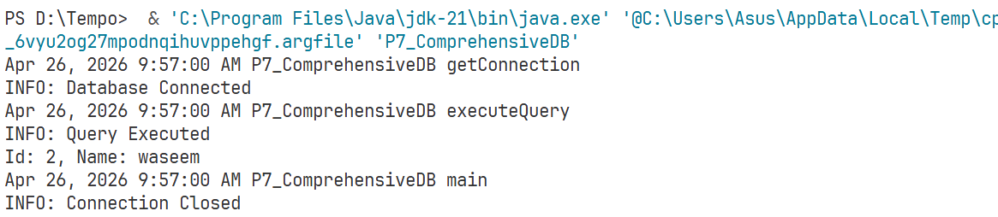
Week 11
Problem 1: DateParse
// You are working on a module for a date management system that handles checked exceptions related to parsing dates. The module should use
// the "try-with-resources" statement to manage the DateFormat object and ensure proper closure of the formatter, even if an exception occurs.

import java.lang.AutoCloseable;
import java.text.*;
import java.util.Date;
class DateFormatException extends Exception{
DateFormatException(String str){
super(str);
}
}
class DateFormatClass implements AutoCloseable {
private DateFormat dateFormat;
DateFormatClass(String pattern){
dateFormat = new SimpleDateFormat(pattern);
dateFormat.setLenient(false);
}
public Date parse(String dateString)throws DateFormatException{
try {
return dateFormat.parse(dateString);
} catch (ParseException e) {
throw new DateFormatException("Unparseable Date: "+dateString);
}
}
@Override
public void close() throws Exception {
System.out.println("DateFormatClass closed");
}
}
public class P1_DateParse{
public static void main(String[] args) {
try(DateFormatClass df = new DateFormatClass("yyyy-MM-dd");){
try {
Date date = df.parse("2025-12-30");
System.out.println("Parsed date: "+date);
} catch (Exception e) {
System.out.println(e);
}
} catch (Exception e) {
System.out.println(e);
}
}
}
Output:
Problem 2: CustomException
// You need to develop a module for a date management system that introduces a custom exception class for representing date parsing-related issues.
// The module should throw this custom exception instead of the generic ParseException when encountering date parsing Problems.

import java.lang.AutoCloseable;
import java.text.*;
import java.util.Date;
class DateFormatException extends Exception{
DateFormatException(String str){
super(str);
}
}
class DateFormatClass implements AutoCloseable {
private DateFormat dateFormat;
DateFormatClass(String pattern){
dateFormat = new SimpleDateFormat(pattern);
dateFormat.setLenient(false);
}
public Date parse(String dateString)throws DateFormatException{
try {
return dateFormat.parse(dateString);
} catch (ParseException e) {
throw new DateFormatException("Unparseable Date: "+dateString);
}
}
@Override
public void close() throws Exception {
System.out.println("DateFormatClass closed");
}
}
public class P2_CustomException{
public static void main(String[] args) {
try(DateFormatClass df = new DateFormatClass("yyyy-MM-dd");){
try {
Date date = df.parse("2025-12-30");
System.out.println("Parsed date: "+date);
} catch (Exception e) {
System.out.println(e);
}
} catch (Exception e) {
System.out.println(e);
}
}
}
Output:
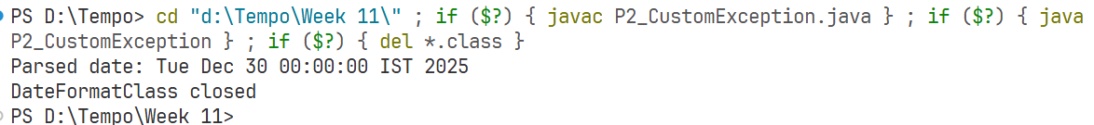
Problem 3: Logging
// You are tasked with writing a module for a date management system that logs the details of date parsing issues using a logging
// framework. The module should handle exceptions gracefully and provide meaningful feedback to the user.

import java.lang.AutoCloseable;
import java.text.*;
import java.util.Date;
import java.util.logging.*;
class DateFormatException extends Exception{
DateFormatException(String str){
super(str);
}
}
class DateFormatClass implements AutoCloseable {
public static Logger logger = Logger.getLogger("MyLogs");
public static FileHandler fileHandler;
static{
try {
fileHandler = new FileHandler("app.log");
fileHandler.setFormatter(new SimpleFormatter());
logger.addHandler(fileHandler);
} catch (Exception e) {
System.out.println(e);
}
}
private DateFormat dateFormat;
DateFormatClass(String pattern){
dateFormat = new SimpleDateFormat(pattern);
dateFormat.setLenient(false);
}
public Date parse(String dateString)throws DateFormatException{
try {
return dateFormat.parse(dateString);
} catch (ParseException e) {
throw new DateFormatException("Unparseable Date: "+dateString);
}
}
@Override
public void close() throws Exception {
System.out.println("DateFormatClass closed");
logger.info("Date format object closed successfully");
}
}
public class P3_Logging{
public static Logger logger = Logger.getLogger("MyLogs");
public static FileHandler fileHandler;
static{
try {
fileHandler = new FileHandler("app.log");
fileHandler.setFormatter(new SimpleFormatter());
logger.addHandler(fileHandler);
} catch (Exception e) {
System.out.println(e);
}
}
public static void main(String[] args) {
try(DateFormatClass df = new DateFormatClass("yyyy-MM-dd");){
String dateString = "2025-12-30";
try {
Date date = df.parse(dateString);
System.out.println("Parsed date: "+date);
logger.info("Parsed date: "+ date);
} catch (Exception e) {
logger.severe("Unparseable Date: "+dateString);
System.out.println(e);
}
} catch (Exception e) {
System.out.println(e);
}
}
}
Output:
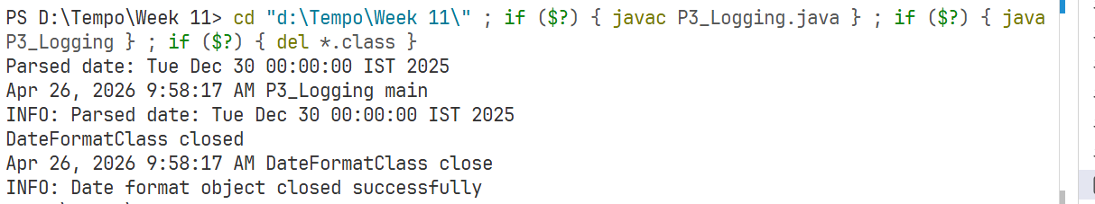
Problem 4: AdvException
// You need to develop a module for a date management system that uses advanced exception handling techniques, including a finally
// block to log a message indicating the successful closure of the DateFormat object, regardless of whether an exception occurred.

import java.lang.AutoCloseable;
import java.text.*;
import java.util.Date;
import java.util.logging.*;
class DateFormatException extends Exception{
DateFormatException(String str){
super(str);
}
}
class DateFormatClass implements AutoCloseable {
public static Logger logger = Logger.getLogger("MyLogs");
public static FileHandler fileHandler;
static{
try {
fileHandler = new FileHandler("app.log");
fileHandler.setFormatter(new SimpleFormatter());
logger.addHandler(fileHandler);
} catch (Exception e) {
System.out.println(e);
}
}
private DateFormat dateFormat;
DateFormatClass(String pattern){
dateFormat = new SimpleDateFormat(pattern);
dateFormat.setLenient(false);
}
public Date parse(String dateString)throws DateFormatException{
try {
return dateFormat.parse(dateString);
} catch (ParseException e) {
throw new DateFormatException("Unparseable Date: "+dateString);
}
}
@Override
public void close() throws Exception {
System.out.println("DateFormatClass closed");
logger.info("Date format object closed successfully");
}
}
public class P4_AdvException{
public static Logger logger = Logger.getLogger("MyLogs");
public static FileHandler fileHandler;
static{
try {
fileHandler = new FileHandler("app.log");
fileHandler.setFormatter(new SimpleFormatter());
logger.addHandler(fileHandler);
} catch (Exception e) {
System.out.println(e);
}
}
public static void main(String[] args) {
DateFormatClass df=null;
try{
df = new DateFormatClass("yyyy-MM-dd");
String dateString = "2025-12-30";
try {
Date date = df.parse(dateString);
System.out.println("Parsed date: "+date);
logger.info("Parsed date: "+ date);
} catch (Exception e) {
logger.severe("Unparseable Date: "+dateString);
System.out.println(e);
}
} catch (Exception e) {
System.out.println(e);
logger.severe("Error Occured: "+e);
} finally{
try {
df.close();
} catch (Exception e) {
System.out.println(e);
}
}
}
}
Output:
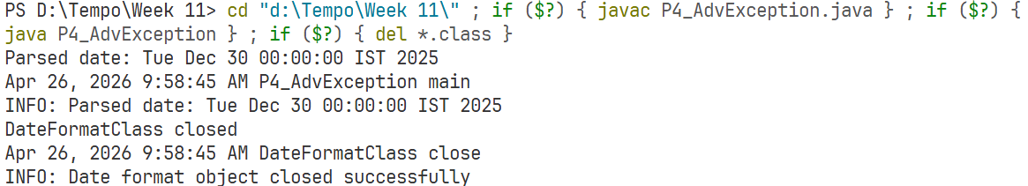
Problem 5: CheckedException
// You are tasked with writing a module for a date management system that handles checked exceptions related to date operations.
// The module should use advanced techniques for exception handling and resource management.

import java.lang.AutoCloseable;
import java.text.*;
import java.util.Date;
class DateFormatException extends Exception{
DateFormatException(String str){
super(str);
}
}
class DateFormatClass implements AutoCloseable {
private DateFormat dateFormat;
DateFormatClass(String pattern){
dateFormat = new SimpleDateFormat(pattern);
dateFormat.setLenient(false);
}
public Date parse(String dateString)throws DateFormatException{
try {
return dateFormat.parse(dateString);
} catch (ParseException e) {
throw new DateFormatException("Unparseable Date: "+dateString);
}
}
@Override
public void close() throws Exception {
System.out.println("DateFormatClass closed");
}
}
public class P5_CheckedException{
public static void main(String[] args) {
try(DateFormatClass df = new DateFormatClass("yyyy-MM-dd");){
try {
Date date = df.parse("2025-12-30");
System.out.println("Parsed date: "+date);
} catch (Exception e) {
System.out.println(e);
}
} catch (Exception e) {
System.out.println(e);
}
}
}
Output:
Problem 6: Custom
// You need to develop a module for a date management system that introduces a custom exception class for representing date operation-related issues.
// The module should throw this custom exception instead of the generic ParseException when encountering date operation Problems.

import java.lang.AutoCloseable;
import java.text.*;
import java.util.Date;
class DateFormatException extends Exception{
DateFormatException(String str){
super(str);
}
}
class DateFormatClass implements AutoCloseable {
private DateFormat dateFormat;
DateFormatClass(String pattern){
dateFormat = new SimpleDateFormat(pattern);
dateFormat.setLenient(false);
}
public Date parse(String dateString)throws DateFormatException{
try {
return dateFormat.parse(dateString);
} catch (ParseException e) {
throw new DateFormatException("Unparseable Date: "+dateString);
}
}
@Override
public void close() throws Exception {
System.out.println("DateFormatClass closed");
}
}
public class P6_Custom{
public static void main(String[] args) {
try(DateFormatClass df = new DateFormatClass("yyyy-MM-dd");){
try {
Date date = df.parse("2025-12-30");
System.out.println("Parsed date: "+date);
} catch (Exception e) {
System.out.println(e);
}
} catch (Exception e) {
System.out.println(e);
}
}
}
Output:
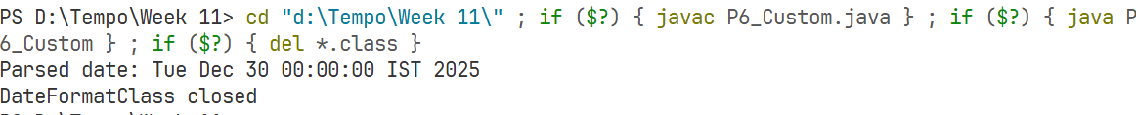
Problem 7: ComException
// You are tasked with writing a comprehensive exception handling module for a date management system that handles various
// checked exceptions, logs the details, and ensures proper closure of date formatters.

import java.lang.AutoCloseable;
import java.text.*;
import java.util.Date;
import java.util.logging.*;
class DateFormatException extends Exception{
DateFormatException(String str){
super(str);
}
}
class DateFormatClass implements AutoCloseable {
public static Logger logger = Logger.getLogger("MyLogs");
public static FileHandler fileHandler;
static{
try {
fileHandler = new FileHandler("app.log");
fileHandler.setFormatter(new SimpleFormatter());
logger.addHandler(fileHandler);
} catch (Exception e) {
System.out.println(e);
}
}
private DateFormat dateFormat;
DateFormatClass(String pattern){
dateFormat = new SimpleDateFormat(pattern);
dateFormat.setLenient(false);
}
public Date parse(String dateString)throws DateFormatException{
try {
return dateFormat.parse(dateString);
} catch (ParseException e) {
throw new DateFormatException("Unparseable Date: "+dateString);
}
}
@Override
public void close() throws Exception {
System.out.println("DateFormatClass closed");
logger.info("Date format object closed successfully");
}
}
public class P7_ComException{
public static Logger logger = Logger.getLogger("MyLogs");
public static FileHandler fileHandler;
static{
try {
fileHandler = new FileHandler("app.log");
fileHandler.setFormatter(new SimpleFormatter());
logger.addHandler(fileHandler);
} catch (Exception e) {
System.out.println(e);
}
}
public static void main(String[] args) {
try(DateFormatClass df = new DateFormatClass("yyyy-MM-dd");){
String dateString = "2025-12-30";
try {
Date date = df.parse(dateString);
System.out.println("Parsed date: "+date);
logger.info("Parsed date: "+ date);
} catch (Exception e) {
logger.severe("Unparseable Date: "+dateString);
System.out.println(e);
}
} catch (Exception e) {
System.out.println(e);
}
}
}
Output:
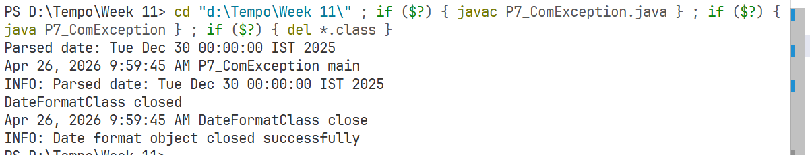
Week 12
Problem 1: NetworkConnection
// You are working on a module for a network management system that handles checked exceptions related to establishing network
// connections.The module should use the "try-with-resources" statement to manage the HttpURLConnection object and ensure proper
// closure of the connection, even if an exception occurs.

import java.io.*;
import java.net.*;
class Connection implements AutoCloseable {
public HttpURLConnection conn;
Connection(String urlString) throws IOException, URISyntaxException {
URL url = new URI(urlString).toURL();
conn = (HttpURLConnection) url.openConnection();
}
@Override
public void close() throws Exception {
if (conn != null) {
conn.disconnect();
}
System.out.println("Connection Closed.");
}
}
public class P1_NetworkConnection {
public static void main(String[] args) {
try (Connection connection = new Connection("http://example.com");
BufferedReader br = new BufferedReader(new InputStreamReader(connection.conn.getInputStream()))) {
System.out.println("Connection Succesfull");

try {
String line;
while ((line = br.readLine()) != null) {
System.out.println(line);
}
} catch (IOException e) {
System.out.println("IOException: Valid URL, but an exception occurs during the operation\n" + e);
} catch (Exception e) {
System.out.println(e);
} catch (IOException e) {
System.out.println("IOException: Could not connect to URL.");
} catch (URISyntaxException e) {
System.out.println("URISyntaxException" + e);
} catch (Exception e) { System.out.println("Exception" + e);}}}
Output:
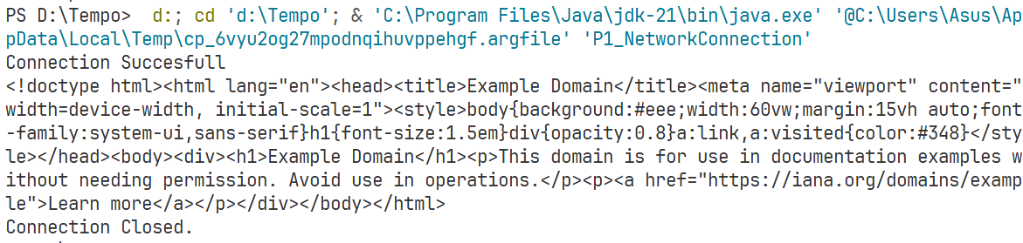
Problem 2: CustomException
// You need to develop a module for a network management system that introduces a custom exception class for representing network
// connection-related issues. The module should throw this custom exception instead of the generic IOException when encountering
// network connection Problems.

import java.io.*;
import java.net.*;
class CustomException extends Exception{
CustomException(String str){
super(str);
}
}
class Connection implements AutoCloseable{
public HttpURLConnection conn;
Connection(String urlString) throws CustomException{
try {
URL url = new URI(urlString).toURL();
conn = (HttpURLConnection) url.openConnection();
} catch (Exception e) {
throw new CustomException("Could not connect to URL.");
}
}

@Override
public void close() throws Exception {
if(conn!=null){
conn.disconnect();
}
System.out.println("Connection Closed.");
}
}
public class P2_CustomException {

public static BufferedReader getReader(HttpURLConnection conn) throws CustomException{
try {
return new BufferedReader(new InputStreamReader(conn.getInputStream()));
} catch (IOException e) {
throw new CustomException("Could not connect to URL");
}

}
public static void main(String[] args) {
try(Connection connection = new Connection("http://examplecom");
BufferedReader br = getReader(connection.conn)){
System.out.println("Connection Succesfull");

try {
String line;
while((line = br.readLine())!=null){
System.out.println(line);
}
} catch (IOException e) {
throw new CustomException("IOException: Valid URL, but an exception occurs during the operation\n"+e);
}

} catch (IOException e) {
System.out.println("IOException: Could not connect to URL.");
} catch(URISyntaxException e){
System.out.println("URISyntaxException"+e);
} catch(Exception e){
System.out.println("Exception"+e);
}
}
}
Output:
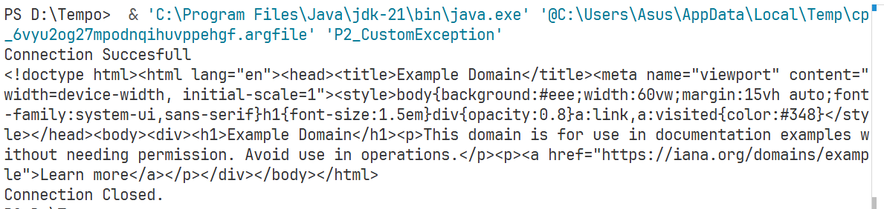
Problem 3: Logging
// You are tasked with writing a module for a network management system that logs the details of network connection issues using
// a logging framework. The module should handle exceptions gracefully and provide meaningful feedback to the user.

import java.io.*;
import java.net.*;
import java.util.logging.*;
class CustomException extends Exception{
CustomException(String str){
super(str);
}
}
class Connection implements AutoCloseable{
public HttpURLConnection conn;
Connection(String urlString) throws CustomException{
try {
URL url = new URI(urlString).toURL();
conn = (HttpURLConnection) url.openConnection();
} catch (Exception e) {
throw new CustomException("Could not connect to URL.");
}
}

@Override
public void close() throws Exception {
if(conn!=null){
conn.disconnect();
}
P3_Logging.logger.info("Connection Closed");
System.out.println("Connection Closed.");
}
}
public class P3_Logging {
public static Logger logger = Logger.getLogger("MyLogs");
public static FileHandler fileHandler;
static{
try {
fileHandler = new FileHandler("app.log");
fileHandler.setFormatter(new SimpleFormatter());
logger.addHandler(fileHandler);
} catch (Exception e) {
System.out.println(e);
}
}
public static BufferedReader getReader(HttpURLConnection conn) throws CustomException{
try {
return new BufferedReader(new InputStreamReader(conn.getInputStream()));
} catch (IOException e) {
logger.severe("Could not connect to URL");
throw new CustomException("Could not connect to URL");
}

}
public static void main(String[] args) {
try(Connection connection = new Connection("http://examplecom");
BufferedReader br = getReader(connection.conn)){
logger.info("Connection Succesfull");
System.out.println("Connection Succesfull");

try {
String line;
while((line = br.readLine())!=null){
System.out.println(line);
}
} catch (IOException e) {
logger.severe("IOException: Valid URL, but an exception occurs during the operation\n"+e);
throw new CustomException("IOException: Valid URL, but an exception occurs during the operation\n"+e);
}

} catch (CustomException e) {
logger.severe("Could not connect to URL.");
System.out.println("Could not connect to URL.");
} catch(Exception e){
logger.severe("Exception: "+e);
System.out.println("Exception"+e);
}
}
}
Output:
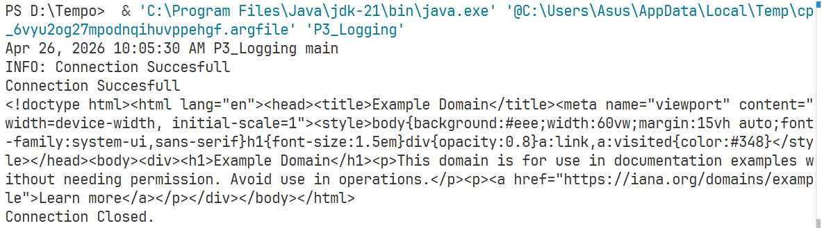
Problem 4: AdvException
// You need to develop a module for a network management system that uses advanced exception handling techniques, including a finally block
// to log a message indicating the successful closure of the HttpURLConnection object, regardless of whether an exception occurred.

import java.io.*;
import java.net.*;
import java.util.logging.*;
class CustomException extends Exception{
CustomException(String str){
super(str);
}
}
class Connection implements AutoCloseable{
public HttpURLConnection conn;
Connection(String urlString) throws CustomException{
try {
URL url = new URI(urlString).toURL();
conn = (HttpURLConnection) url.openConnection();
} catch (Exception e) {
throw new CustomException("Could not connect to URL.");
}
}

@Override
public void close() throws Exception {
if(conn!=null){
conn.disconnect();
}
P3_Logging.logger.info("Connection Closed");
System.out.println("Connection Closed.");
}
}
public class P4_AdvException {public static Logger logger = Logger.getLogger("MyLogs");
public static FileHandler fileHandler;
static{
try {
fileHandler = new FileHandler("app.log");
fileHandler.setFormatter(new SimpleFormatter());
logger.addHandler(fileHandler);
} catch (Exception e) {
System.out.println(e);
}
}
public static BufferedReader getReader(HttpURLConnection conn) throws CustomException{
try {
return new BufferedReader(new InputStreamReader(conn.getInputStream()));
} catch (IOException e) {
logger.severe("Could not connect to URL");
throw new CustomException("Could not connect to URL");
}

}
public static void main(String[] args) {
Connection connection=null;
BufferedReader br=null;
try{
connection = new Connection("http://example.com");
br = getReader(connection.conn);
logger.info("Connection Succesfull");
System.out.println("Connection Succesfull");

try {
String line;
while((line = br.readLine())!=null){
System.out.println(line);
}
} catch (IOException e) {
logger.severe("IOException: Valid URL, but an exception occurs during the operation\n"+e);
throw new CustomException("IOException: Valid URL, but an exception occurs during the operation\n"+e);
}

} catch (CustomException e) {
logger.severe("Could not connect to URL.");
System.out.println("Could not connect to URL.");
} catch(Exception e){
logger.severe("Exception: "+e);
System.out.println("Exception"+e);
} finally{
if(connection!=null){
connection.conn.disconnect();
try {
if(br!=null)
br.close();
} catch (IOException e) {
System.out.println(e);
}
}
}
}
}
Output:
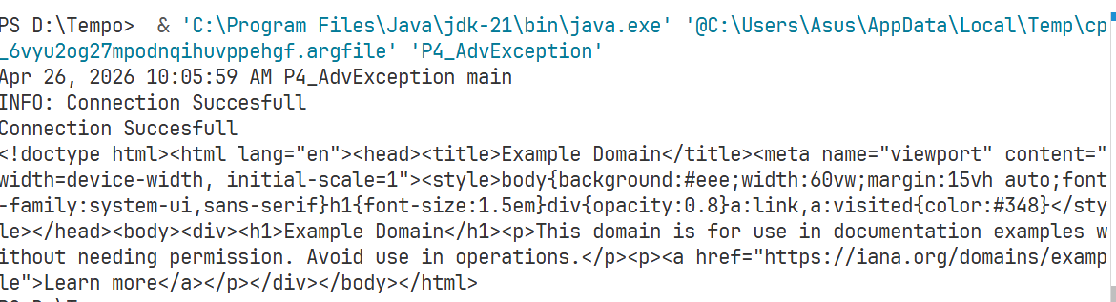
Problem 5: CheckedException
// You are tasked with writing a module for a network management system that handles checked exceptions related to network
// operations. The module should use advanced techniques for exception handling and resource management.

import java.io.*;
import java.net.*;
class CustomException extends Exception{
CustomException(String str){
super(str);
}
}
class Connection implements AutoCloseable{
public HttpURLConnection conn;
Connection(String urlString) throws CustomException{
try {
URL url = new URI(urlString).toURL();
conn = (HttpURLConnection) url.openConnection();
} catch (Exception e) {
throw new CustomException("Could not connect to URL.");
}
}

@Override
public void close() throws Exception {
if(conn!=null){
conn.disconnect();
}
System.out.println("Connection Closed.");
}
}
public class P5_CheckedException {

public static BufferedReader getReader(HttpURLConnection conn) throws CustomException{
try {
return new BufferedReader(new InputStreamReader(conn.getInputStream()));
} catch (IOException e) {
throw new CustomException("Could not connect to URL");
}

}
public static void main(String[] args) {
try(Connection connection = new Connection("http://example.com");
BufferedReader br = getReader(connection.conn)){
System.out.println("Connection Succesfull");

try {
String line;
while((line = br.readLine())!=null){
System.out.println(line);
}
} catch (IOException e) {
throw new CustomException("IOException: Valid URL, but an exception occurs during the operation\n"+e);
}

} catch (IOException e) {
System.out.println("IOException: Could not connect to URL.");
} catch(URISyntaxException e){
System.out.println("URISyntaxException"+e);
} catch(Exception e){
System.out.println("Exception"+e);
}
}
}
Output:
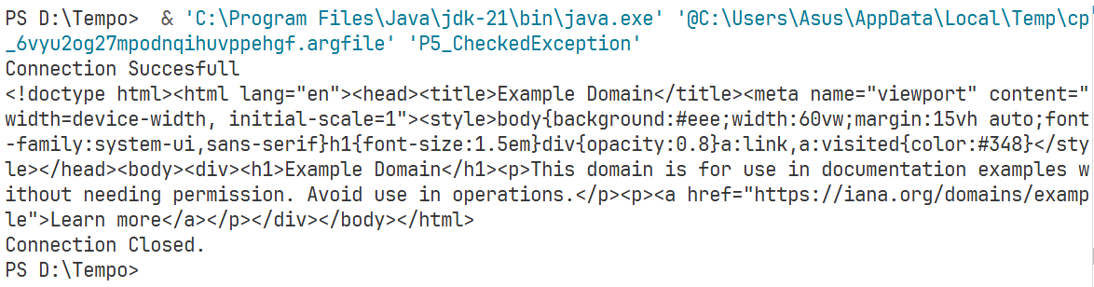
Problem 6: CustomException
// You need to develop a module for a network management system that introduces a custom exception class for representing network operation-related
// issues.The module should throw this custom exception instead of the generic IOException when encountering network operation Problems.

import java.io.*;
import java.net.*;
class CustomException extends Exception{
CustomException(String str){
super(str);
}
}
class Connection implements AutoCloseable{
public HttpURLConnection conn;
Connection(String urlString) throws CustomException{
try {
URL url = new URI(urlString).toURL();
conn = (HttpURLConnection) url.openConnection();
} catch (Exception e) {
throw new CustomException("Could not connect to URL.");
}
}

@Override
public void close() throws Exception {
if(conn!=null){
conn.disconnect();
}
System.out.println("Connection Closed.");
}
}
public class P6_CustomException {

public static BufferedReader getReader(HttpURLConnection conn) throws CustomException{
try {
return new BufferedReader(new InputStreamReader(conn.getInputStream()));
} catch (IOException e) {
throw new CustomException("Could not connect to URL");
}

}
public static void main(String[] args) {
try(Connection connection = new Connection("http://example.com");
BufferedReader br = getReader(connection.conn)){
System.out.println("Connection Succesfull");

try {
String line;
while((line = br.readLine())!=null){
System.out.println(line);
}
} catch (IOException e) {
throw new CustomException("IOException: Valid URL, but an exception occurs during the operation\n"+e);
}

} catch (IOException e) {
System.out.println("IOException: Could not connect to URL.");
} catch(URISyntaxException e){
System.out.println("URISyntaxException"+e);
} catch(Exception e){
System.out.println("Exception"+e);
}
}
}
Output:
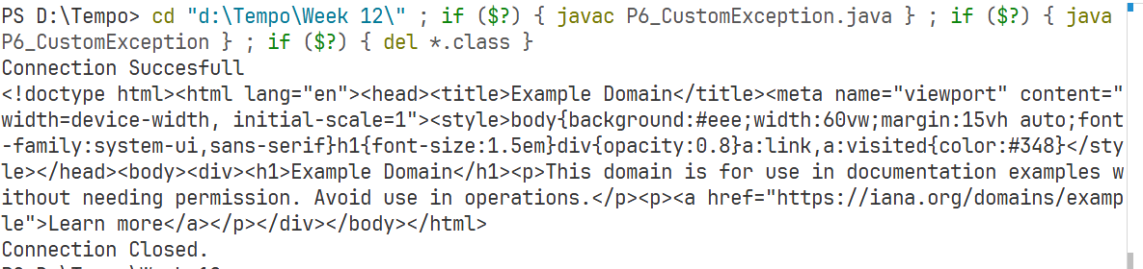
Problem 7: Comprehensive
// You are tasked with writing a comprehensive exception handling module for a network management system that handles
// various checked exceptions, logs the details, and ensures proper closure of network connections.

import java.io.*;
import java.net.*;
import java.util.logging.*;
class CustomException extends Exception{
CustomException(String str){
super(str);
}
}
class Connection implements AutoCloseable{
public HttpURLConnection conn;
Connection(String urlString) throws CustomException{
try {
URL url = new URI(urlString).toURL();
conn = (HttpURLConnection) url.openConnection();
} catch (Exception e) {
throw new CustomException("Could not connect to URL.");
}
}

@Override
public void close() throws Exception {
if(conn!=null){
conn.disconnect();
}
P3_Logging.logger.info("Connection Closed");
System.out.println("Connection Closed.");
}
}
public class P7_Comprehensive {public static Logger logger = Logger.getLogger("MyLogs");
public static FileHandler fileHandler;
static{
try {
fileHandler = new FileHandler("app.log");
fileHandler.setFormatter(new SimpleFormatter());
logger.addHandler(fileHandler);
} catch (Exception e) {
System.out.println(e);
}
}
public static BufferedReader getReader(HttpURLConnection conn) throws CustomException{
try {
return new BufferedReader(new InputStreamReader(conn.getInputStream()));
} catch (IOException e) {
logger.severe("Could not connect to URL");
throw new CustomException("Could not connect to URL");
}

}
public static void main(String[] args) {
Connection connection=null;
BufferedReader br=null;
try{
connection = new Connection("http://example.com");
br = getReader(connection.conn);
logger.info("Connection Succesfull");
System.out.println("Connection Succesfull");

try {
String line;
while((line = br.readLine())!=null){
System.out.println(line);
}
} catch (IOException e) {
logger.severe("IOException: Valid URL, but an exception occurs during the operation\n"+e);
throw new CustomException("IOException: Valid URL, but an exception occurs during the operation\n"+e);
}

} catch (CustomException e) {
logger.severe("Could not connect to URL.");
System.out.println("Could not connect to URL.");
} catch(Exception e){
logger.severe("Exception: "+e);
System.out.println("Exception"+e);
} finally{
if(connection!=null){
connection.conn.disconnect();
try {
if(br!=null)
br.close();
} catch (IOException e) {
System.out.println(e);
}
}
}
}
}
Output:

Week 13
Problem 1: FileInput
import java.io.*;
public class P1_FileInput {
public static void readFile(String filePath) {
try (FileReader fr = new FileReader(filePath)) {
int data;
StringBuilder content = new StringBuilder();

while ((data = fr.read()) != -1) {
content.append((char) data);
}
if (content.length() == 0) {
throw new IOException("An error occurred during file reading.");
}
System.out.println("File content: " + content);
} catch (FileNotFoundException e) {
System.out.println("Exception: FileNotFoundException - The file " + filePath + " does not exist.");
} catch (IOException e) {
System.out.println("Exception: IOException - " + e.getMessage());
} finally {
System.out.println("File reader closed");
}
}
public static void main(String[] args) {
readFile("input.txt");
}
}
Output:
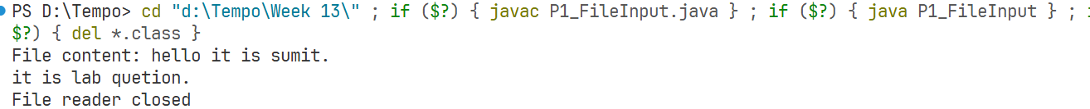
Problem 2: FileInputCustom
import java.io.*;
class FileInputException extends Exception{
public FileInputException(String message){
super(message);
}
}
public class P2_FileInputCustom{
public static void readFile(String filePath){
try(FileReader fr=new FileReader(filePath)){
int data;
StringBuilder content=new StringBuilder();
while((data=fr.read())!=-1){
content.append((char)data);
}
if(content.length()==0){
throw new FileInputException("An error occurred during file reading.");
}
System.out.println("File content: "+content);
}catch(FileNotFoundException e){
System.out.println("Exception: FileInputException - The file "+filePath+" does not exist.");
}catch(FileInputException e){
System.out.println("Exception: FileInputException - "+e.getMessage());
}catch(IOException e){
System.out.println("Exception: FileInputException - An error occurred during file reading.");
}finally{
System.out.println("File reader closed");
}
}
public static void main(String[] args){
readFile("input.txt");
}
}
Output:
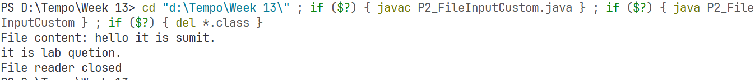
Problem 3: FileInputLogging
import java.io.*;
import java.util.logging.*;
class FileInputException extends Exception{
public FileInputException(String message){
super(message);
}
}
public class P3_FileInputLogging{
private static final Logger logger=Logger.getLogger("MyLogs");
static{
try{
FileHandler fh=new FileHandler("app.log",true);
fh.setFormatter(new SimpleFormatter());
logger.addHandler(fh);
}catch(IOException e){
System.out.println("Logger setup failed");
}
}
public static void readFile(String filePath){
try(FileReader fr=new FileReader(filePath)){
int data;
StringBuilder content=new StringBuilder();
while((data=fr.read())!=-1){
content.append((char)data);
}
if(content.length()==0){
throw new FileInputException("An error occurred during file reading.");
}
System.out.println("File content: "+content);
logger.info("Data Readen from file");
}catch(FileNotFoundException e){
System.out.println("Exception: FileInputException - The file "+filePath+" does not exist.");
logger.severe("FileInputException occurred.");
}catch(FileInputException e){
System.out.println("Exception: FileInputException - "+e.getMessage());
logger.severe("FileInputException occurred.");
}catch(IOException e){
System.out.println("Exception: FileInputException - An error occurred during file reading.");
logger.severe("FileInputException occurred.");
}
finally{
System.out.println("File reader closed");}}
public static void main(String[] args){
readFile("input.txt");
}
}
Output:
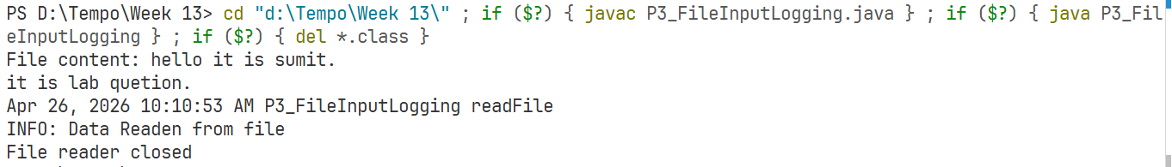
Problem 4: AdvancedException
import java.io.*;
import java.util.logging.*;
class FileInputException extends Exception{
public FileInputException(String message){
super(message);
}
}
public class P4_AdvancedException{
private static final Logger logger=Logger.getLogger(P4_AdvancedException.class.getName());
static{
try{
FileHandler fh=new FileHandler("app.log",true);
fh.setFormatter(new SimpleFormatter());
logger.addHandler(fh);
}catch(IOException e){
System.out.println("Logger setup failed");
}
}
public static void readFile(String filePath){
try(FileReader fr=new FileReader(filePath)){
int data;
StringBuilder content=new StringBuilder();
while((data=fr.read())!=-1){
content.append((char)data);
}
if(content.length()==0){
throw new FileInputException("An error occurred during file reading.");
}
System.out.println("File content: "+content);
System.out.println("File reader closed");
}catch(FileNotFoundException e){
System.out.println("Exception: FileInputException - The file "+filePath+" does not exist.");
logger.severe("FileInputException occurred.");
}catch(FileInputException e){
System.out.println("Exception: FileInputException - "+e.getMessage());
logger.severe("FileInputException occurred.");
}catch(IOException e){
System.out.println("Exception: FileInputException - An error occurred during file reading.");
logger.severe("FileInputException occurred.");
}finally{
System.out.println("File Reader closed.");
logger.info("FileReader object closed successfully.");}}
public static void main(String[] args){
readFile("input.txt");}}
Output:
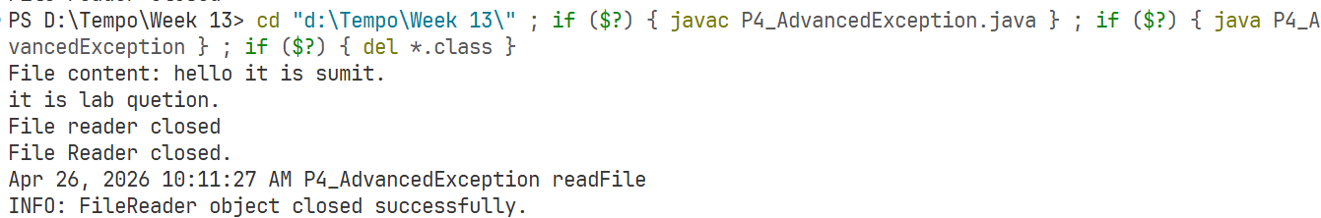
Problem 5: FileOperations
import java.io.*;
import java.util.logging.*;
class FileOperationException extends Exception{
public FileOperationException(String message){
super(message);
}
}
public class P5_FileOperations{
private static final Logger logger=Logger.getLogger(P5_FileOperations.class.getName());
static{
try{
FileHandler fh=new FileHandler("app.log",true);
fh.setFormatter(new SimpleFormatter());
logger.addHandler(fh);
logger.setUseParentHandlers(false);
}catch(IOException e){
System.out.println("Logger setup failed");
}
}
public static void processFile(String filePath){
try(FileReader fr=new FileReader(filePath);
BufferedReader br=new BufferedReader(fr)){
String line;
StringBuilder content=new StringBuilder();
while((line=br.readLine())!=null){
content.append(line);
}
if(content.length()==0){
throw new FileOperationException("An error occurred during file processing.");
}
System.out.println("File content: "+content);
}catch(FileNotFoundException e){
System.out.println("Exception: FileOperationException - The file "+filePath+" does not exist.");
logger.severe("FileOperationException occurred.");
}catch(FileOperationException e){
System.out.println("Exception: FileOperationException - "+e.getMessage());
logger.severe("FileOperationException occurred.");
}catch(IOException e){
System.out.println("Exception: FileOperationException - An error occurred during file processing.");
logger.severe("FileOperationException occurred.");
}finally{
logger.info("File resources closed successfully.");
System.out.println("File resources closed successfully.");
}
}
public static void main(String[] args){
processFile("input.txt");
}
}
Output:
Problem 6: CustomException
import java.io.*;
import java.util.logging.*;
class FileOperationException extends Exception{
public FileOperationException(String message){
super(message);
}
}
public class P6_CustomException{
private static final Logger logger=Logger.getLogger("MyLogs");
static{
try{
FileHandler fh=new FileHandler("app.log",true);
fh.setFormatter(new SimpleFormatter());
logger.addHandler(fh);
logger.setUseParentHandlers(false);
}catch(IOException e){
System.out.println("Logger setup failed");
}
}
public static void processFile(String filePath){
try(FileReader fr=new FileReader(filePath);
BufferedReader br=new BufferedReader(fr)){
String line;
StringBuilder content=new StringBuilder();
while((line=br.readLine())!=null){
content.append(line);
}
if(content.length()==0){
throw new FileOperationException("An error occurred during file processing.");
}
System.out.println("File content: "+content);
}catch(FileNotFoundException e){
System.out.println("Exception: FileOperationException - The file "+filePath+" does not exist.");
logger.severe("FileOperationException occurred.");
}catch(FileOperationException e){
System.out.println("Exception: FileOperationException - "+e.getMessage());
logger.severe("FileOperationException occurred.");
}catch(IOException e){
System.out.println("Exception: FileOperationException - An error occurred during file processing.");
logger.severe("FileOperationException occurred.");
}finally{
logger.info("File resources closed successfully.");
System.out.println("File resources closed successfully.");
}
}
public static void main(String[] args){
processFile("input.txt");
}
}
Output:
Problem 7: ComExceptionHandling
import java.io.*;
import java.util.logging.*;
class FileInputException extends Exception{
public FileInputException(String message){
super(message);
}
}
public class P7_ComExceptionHandling{
private static final Logger logger=Logger.getLogger("MyLogs");
static{
try{
FileHandler fh=new FileHandler("app.log",true);
fh.setFormatter(new SimpleFormatter());
logger.addHandler(fh);
}catch(IOException e){
System.out.println("Logger setup failed");
}}
public static void readFile(String filePath){
try(FileReader fr=new FileReader(filePath)){
int data;
StringBuilder content=new StringBuilder();
while((data=fr.read())!=-1){
content.append((char)data);
}
if(content.length()==0){
throw new FileInputException("An error occurred during file reading.");
}
System.out.println("File content: "+content);
logger.info("Data Readen from file");
}catch(FileNotFoundException e){
System.out.println("Exception: FileInputException - The file "+filePath+" does not exist.");
logger.severe("FileInputException occurred.");
}catch(FileInputException e){
System.out.println("Exception: FileInputException - "+e.getMessage());
logger.severe("FileInputException occurred.");
}catch(IOException e){
System.out.println("Exception: FileInputException - An error occurred during file reading.");
logger.severe("FileInputException occurred.");
}
finally{
System.out.println("File reader closed");
}}
public static void main(String[] args){
readFile("input.txt");
}}
Output:
